The Eagle on the Floor

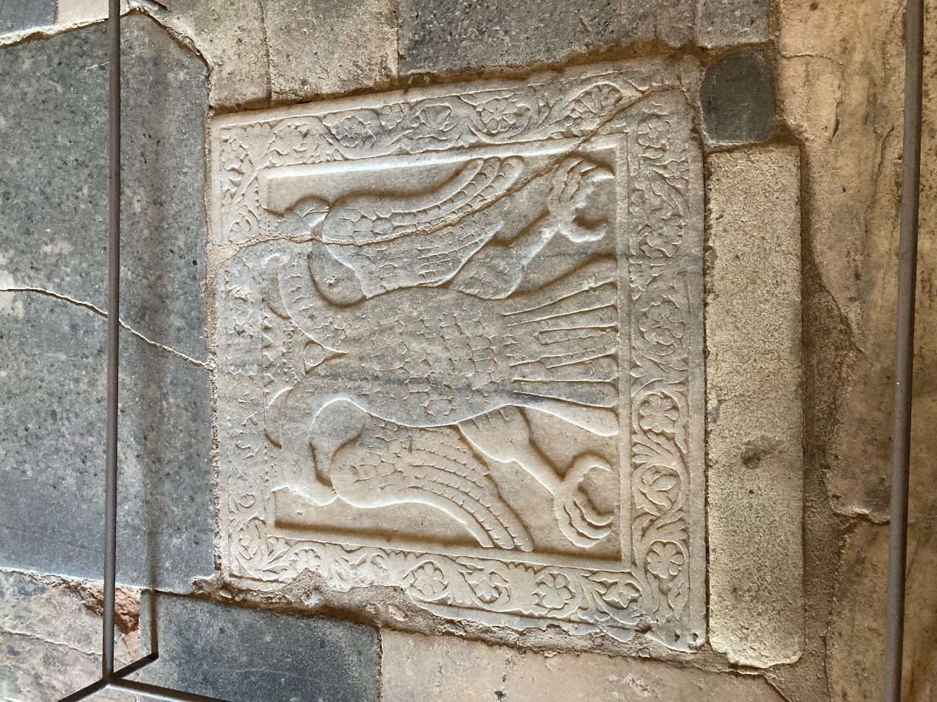
Double-Headed Eagle of the Palaiologos Dynasty, probably 14th century, carved marble relief, Church of Saint Demetrios (Metropolis), Mystras, Laconia, Greece – Photo Credit: Amalia Spiliakou 2026

Student Activity
Here are four student activities inspired by the Double-Headed Eagle of Mystras:

Symbol Detective: Design Your Own Emblem
Have students research what the two heads of the eagle represent (church and state, or East and West) and then design their own two-part symbol representing dual aspects of their own identity, family, or school. They present and explain their choices, just like the Palaiologoi did.

