A Saint in Ivory:
The Icon of Saint Demetrios at The Met

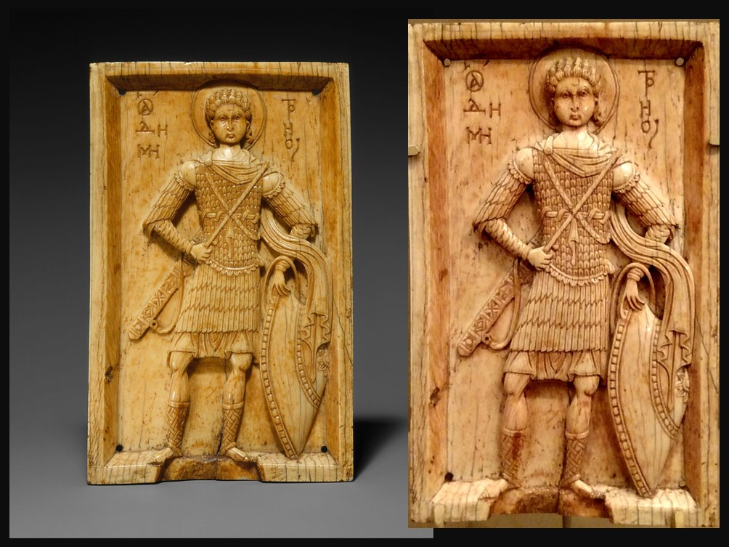
Icon with Saint Demetrios, Byzantine, 950–1000, Elephant Ivory, 19.7x12.1x1cm, the MET, NY, USA
https://www.metmuseum.org/art/collection/search/465946 and https://www.christianiconography.info/metropolitan/medieval5thAvenue/demetriusIvory.html

Student Activity
A Small Object with a Big Story
The ivory panel is only 19.7 × 12.1 cm, yet it may have had several different lives. It may originally have been a devotional object and perhaps even carried into battle or used in a procession. Later, the holes in its back suggest that it may have been reused as a book cover in the Latin West.
Imagine that you are the ivory icon. Write a short ‘biography of an object’
tracing your journey from tenth-century Byzantium to a modern museum.
Include:
- Who might have commissioned or owned you?
- Where might you have been used?
- How might you have travelled from Byzantium to Western Europe?
- Why might someone have changed your original function?
- How might you feel about now being displayed in a museum?

Challenge: Give your biography a title such as The Many Lives of Saint Demetrios.

