Renoir's Peonies: November's Flower of the Month

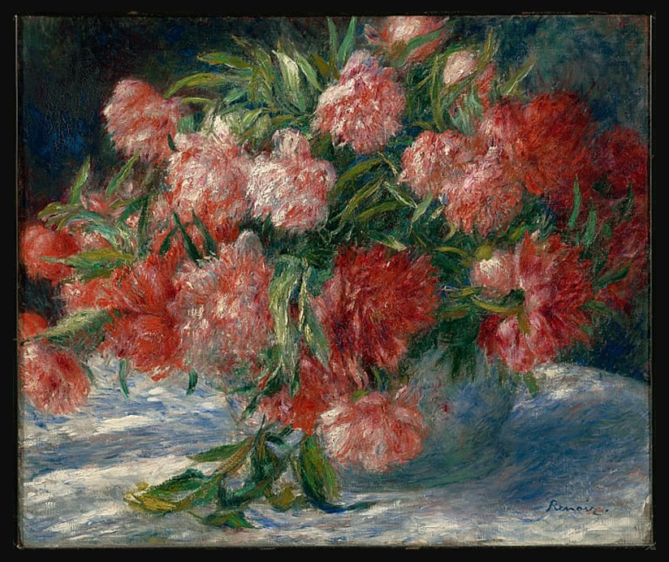
Pierre-Auguste Renoir, French, 1841–1919,
Peonies, c. 1880, Oil on Canvas, 55.3 x 65.7 cm, The Clark Art Institute, MA, USA
https://www.clarkart.edu/ArtPiece/Detail/Peonies?utm_source=chatgpt.com

Student Activities
Here are two Student Activity ideas tied to the artist's key themes, flower symbolism, and ‘resting the brain’ approach:

1. Flower Symbolism Research & Design
Students pick a flower connected to their own birth month (or research the peony's Chinese, Greek, and Victorian meanings in more depth) and design a small still-life composition, sketched or painted, that reflects that flower's symbolic meaning through color and arrangement choices, the way Renoir's loose, tumbling peonies suggest abundance and fleeting beauty.

2. ‘Resting the Brain’ Journal Sketch
Renoir treated flower painting as a low-pressure, experimental outlet between his larger, more demanding works. Have students keep a week-long sketch journal where they draw a small everyday object (a mug, a plant, fruit) with no goal of ‘getting it right’ just testing mark-making, color, or media. End with a reflection: did working without pressure change how they approached the drawing?

