Ciriaca’s Mosaics: A Husband, a Wife and Two Portraits Across Time

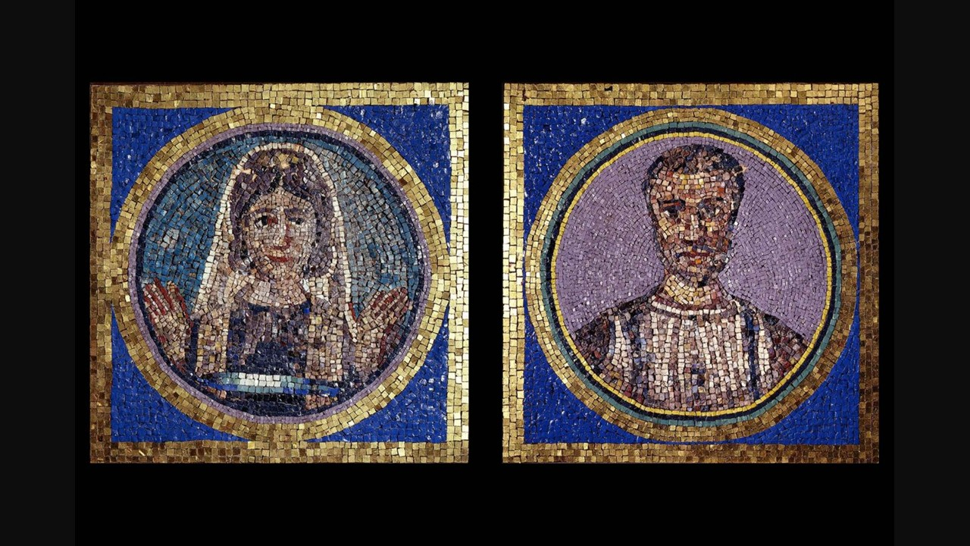
Mosaics of Cyriaca
Left: Clypeus with portrait bust of Maria Simplicia Rustica, around 350 AD, glass paste mosaic, 64 x 64 cm, Musei Vaticani, Italy
https://catalogo.museivaticani.va/index.php/Detail/objects/MV.31584.0.0?lang=en_US
Right: Clypeus with portrait bust of Flavius ​​Iulius Iulianus, about 350 AD, glass paste mosaic, 64 x 64 cm, Musei Vaticani, Italy
https://catalogo.museivaticani.va/index.php/Detail/objects/MV.31585.0.0?lang=en_US

The Ciriaca Mosaics lend themselves particularly well to activities about identity, memory, visual symbolism, and the difference between a portrait and a memorial. Here is an option, ranging from close-looking to hands-on work.

1. 🔍 What Can a Portrait Tell Us?
Focus: Visual analysis and inference
Age: Upper primary–secondary
Give students images of the two mosaic portraits without the explanatory text. Ask them to work in pairs and record:
- What do you notice first?
- How are the two portraits similar?
- What differences can you find?
- What might the woman's raised arms mean?
- What can the portraits tell us about the people depicted?
- What cannot we know simply by looking?
Then reveal the historical information about Maria Simplicia Rustica and Flavius Iulius Iulianus. Students return to their original answers and mark which observations were accurate, which were interpretations, and which changed after learning the story.
Key question: How much can an image tell us about a person—and where does interpretation begin?

