The Sphinx Statue of the Acropolis, Myth, Mystery and an Archaic Smile

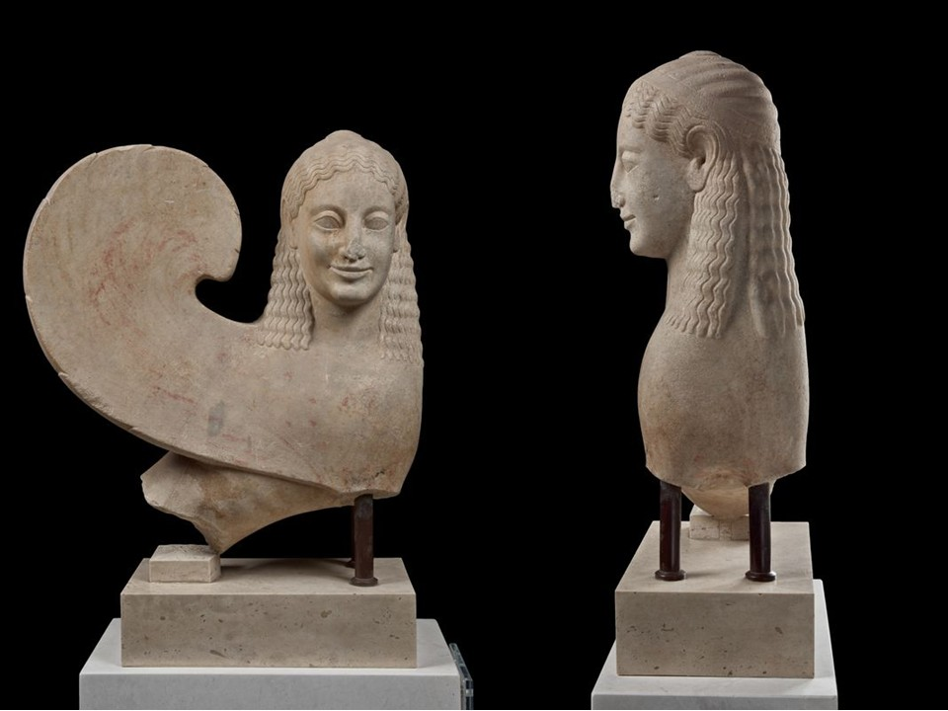
Sphinx Statue, 540-530 BC, Marble from Paros, Height: 0.55 m, Acropolis Museum, Athens, Greece
https://www.theacropolismuseum.gr/en/sphinx-statue-0

Become a Sphinx Detective
Look closely. Think like an archaeologist. Then tell the story.
Study the Sphinx of the Acropolis carefully. Without reading the museum description, write down five things you notice about her appearance.

Then answer:
- What details tell you that this is a mythical creature?
- What does her facial expression make you think or feel?
- How might the sculpture look different if you could see its original red and black colours?
- The Sphinx was originally placed on a tall column. How might seeing her high above you have changed the way you experienced the sculpture?
- What questions would you ask the ancient sculptor?

Now Solve the Mystery
Imagine that you are an ancient Athenian encountering the Sphinx on the Acropolis.
Write 3–5 sentences describing what you might think when you first saw her. Use at least three visual details from the sculpture.
Finally, give your response a title: “The Sphinx Speaks…”

