Autumn at the Vintage: Lucas van Valckenborch and the Rhythm of the Season

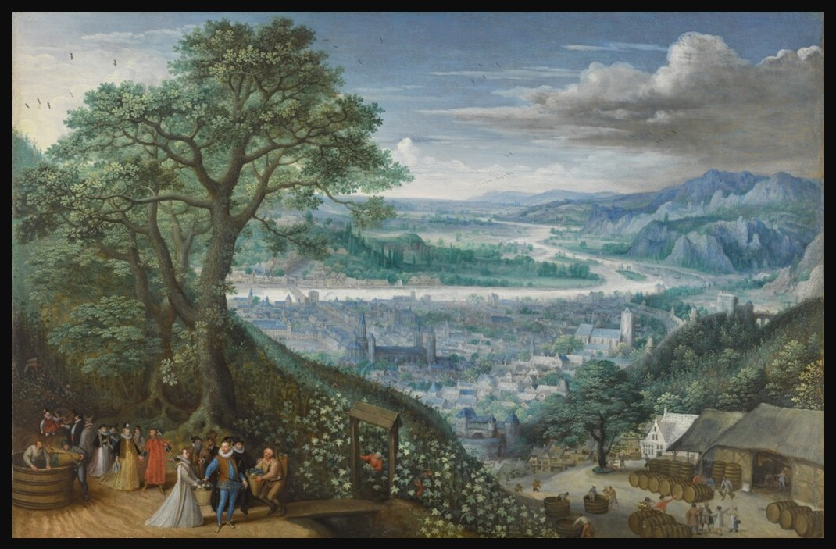
Lucas van Valckenborch, 1535-1597
Autumn: Archduke Matthias of Austria at the Vintage, oil on oak panel, 41 x 63.5 cm, Private Collection
https://www.sothebys.com/en/buy/auction/2025/old-master-19th-century-paintings-evening-auction-l25036/autumn-archduke-matthias-of-austria-with-members

Look, Think, Discover
Take a few minutes to explore Valckenborch's painting without reading its title.
What season do you think it shows? What clues helped you decide?

Then look again.
- Can you find the grape harvest?
- What are the workers doing?
- Where is Archduke Matthias?
- What details tell us that this is a wealthy or important occasion?
- How does the artist create a sense of great distance?
- What might the landscape look like in winter?

Finally, think about your own experience of autumn. What would you include in a painting of autumn today? Falling leaves? School beginning? A harvest? Rainy streets? A favourite walk? Perhaps even a busy September morning.
Valckenborch's painting reminds us that every season tells a story. We only have to stop and look closely enough to see it.


