The Object with No Name: A 2,800-Year-Old Mystery from the Acropolis Slopes

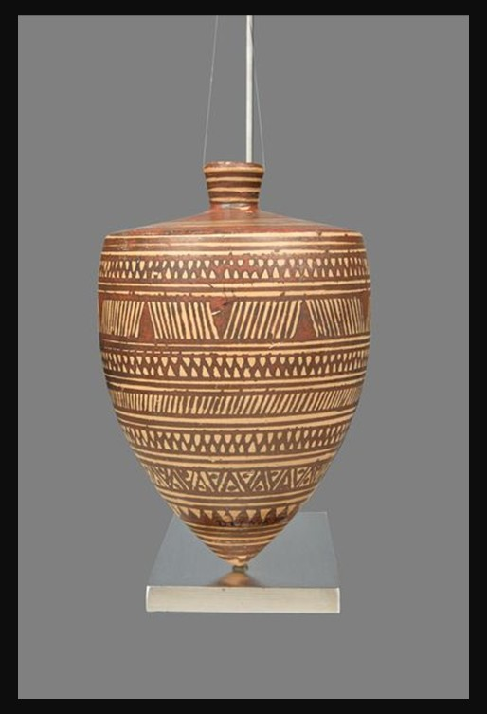
Spinning top, Attic workshop, Geometric Period, 800-760 BC, Clay, Height: 0.127 m, Acropolis Museum, Athens, Greece
https://www.theacropolismuseum.gr/en/spinning-top

Four Student Activities that combine close observation, visual analysis, archaeology, and the productive use of uncertainty, suitable for students, with enough flexibility for different ages.

1. 🔍 Become an Archaeological Detective
Ask students to study the Spinning Top without reading the museum's interpretation.
Task: Write down three observations about its shape, decoration and construction. Then propose three possible uses for the object. For each proposed use, students must give one piece of visual evidence supporting their idea.
Finally, reveal the museum's suggestion that it may have been a spinning top and ask:
Has your interpretation changed? Why or why not?
Learning focus: Observation, visual evidence, archaeological reasoning and distinguishing evidence from assumption.

2. 🌀 Design for Movement
The concentric circles and geometric decoration invite students to think about what happens when an object moves.
Task: Students create a two-dimensional design inspired by the Spinning Top, using only geometric shapes, lines, dots and repeated patterns. Then ask them to imagine the design spinning. What happens to the circles and patterns when the object is in motion?
For an extra challenge, students can create a paper spinner and test their design.
Learning focus: Pattern, repetition, geometry, movement and the relationship between art and design.

3. 🏺 What Is It? The Museum Mystery Challenge
Give students photographs of several ancient objects without their titles or descriptions.
Working in small groups, they must decide:
- What might the object be?
- What might it have been used for?
- Who might have used it?
- Where might it have been found?
- What evidence supports their interpretation?
They then present their conclusions to the class.
The important rule is: students are not allowed to say “I know”; they must say “I think… because…”
Finish by discussing the Acropolis Museum's own cautious wording: “Most possibly it was an actual spinning top.”
Learning focus: Critical thinking, evidence-based interpretation and understanding that archaeological knowledge is sometimes uncertain.

4. 📐 The Geometry of the Geometric Period
Invite students to investigate the decorative vocabulary described in the post: triangles, dots, diagonal lines, wavy lines, horizontal bands and concentric circles.
Task: Create a small “Geometric Period design vocabulary” sheet. Students draw each motif and then combine at least four different motifs to create their own ceramic pattern.
Challenge them to organise the design into horizontal registers, just as the ancient artist did.
Ask: How does repetition make a simple shape visually powerful?
Learning focus: Ancient Greek art, pattern, rhythm, repetition, composition and visual organisation.

Learning focus: Historical thinking, archaeological evidence, uncertainty and the difference between fact and interpretation.

