Sarcophagus of Constantia:
Porphyry, Power and Mystery

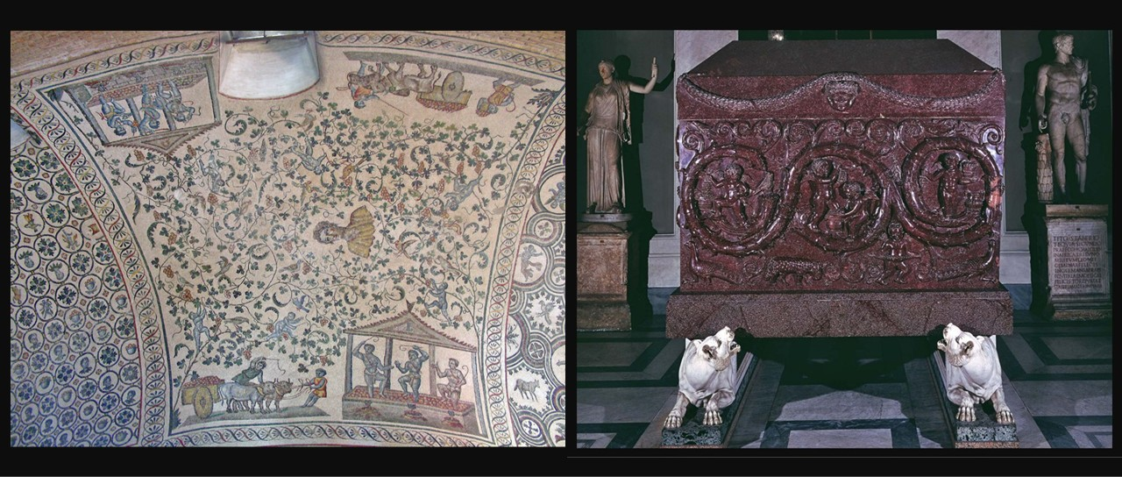
Mosaic in the ambulatory vault of the Mausoleum of Constantina, 4th century AD, Rome, Italy
https://en.wikipedia.org/wiki/Mausoleum_of_Constantina
Monumental sarcophagus of Constance, 354 AD, Red Porphyry, Height 225 cm, Musei Vaticani
https://www.museivaticani.va/content/museivaticani/en/collezioni/musei/museo-pio-clementino/sala-a-croce-greca/sarcofago-di-costanza.html

Choose ONE of the following activities to explore the Sarcophagus of Constantia in greater depth. You may either investigate how artists use symbols to communicate meaning, or imagine the sarcophagus telling its own story after centuries of silence.

Design Your Own Symbolic Sarcophagus
Objective: Students will explore how symbols communicate ideas about identity and belief.
Instructions: Imagine you are designing a modern sarcophagus for an important person today. Include:
- 3 symbols representing the person’s life
- Colours that communicate power or personality
- Decorative patterns or animals
- A short explanation of your choices
Extension: Students can label their drawings with explanations of each symbol.

Creative Writing: “The Stone Speaks”
Objective: Students will explore historical imagination and voice.
Instructions: Write a short monologue from the perspective of the sarcophagus. The sarcophagus might describe:
- Watching emperors and pilgrims pass by
- Being moved through Rome by forty oxen
- Hearing historians argue about its meaning
- Keeping its secrets hidden
Sentence Starter: “I was carved from imperial stone, and for seventeen centuries humans have asked me the same question…”

