When Paris Fell in Love with Japan
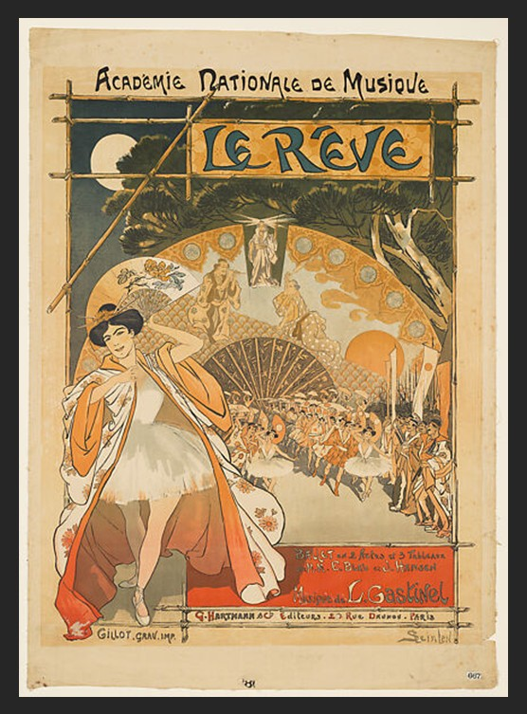
Théophile-Alexandre Steinlen, French 1859–1923 – Printer Charles Gillot
Le Rêve (Académie Nationale de Musique), 1890, Photo relief print (gillotage), 89x63.7 cm, the MET, NY, USA
https://www.metmuseum.org/art/collection/search/788347

Student Activity 1: Become an Art Detective
Title: Finding Japan in a French Poster
Objective: Identify Japanese artistic influences in Steinlen’s print.
Instructions:
Study Le Rêve (Académie Nationale de Musique) carefully. Then answer the following questions:
- Which parts of the composition remind you of Japanese woodblock prints?
- How has the artist used empty space?
- What colors dominate the image? Are they bright or subdued?
- How does the figure interact with the surrounding floral decoration?
- Why do you think European artists found Japanese design so inspiring?
Extension: Write a short paragraph explaining why this artwork is considered an example of Japonism.

Student Activity 2: Debate the Influence of Japonism
Title: Inspiration or Cultural Exchange?
Objective: Think critically about artistic influence.
Read about the popularity of Japanese art in Europe during the late nineteenth century.
Discuss the following questions:
- Why were European artists fascinated by Japanese prints?
- How did Japanese art change Western painting and graphic design?
- Can borrowing ideas from another culture enrich art?
- Do artists today still draw inspiration from other cultures?
Creative Writing Extension
Imagine you are a young artist visiting Paris in 1890.
You have just seen Steinlen’s Le Rêve displayed in a gallery.
Write a diary entry (150–200 words) describing:
- your first impression
- which Japanese elements caught your attention
- why this new style feels different from traditional European art
- how it might influence your own artistic future

These activities encourage students not only to observe Steinlen’s beautiful poster but also to understand how Japonism transformed European art, paving the way for movements such as Art Nouveau, while developing skills in observation, comparison, creativity, and critical thinking.

