Autumn in the Palm of Your Hand: Asters, Chrysanthemums and Two Japanese Inrōs

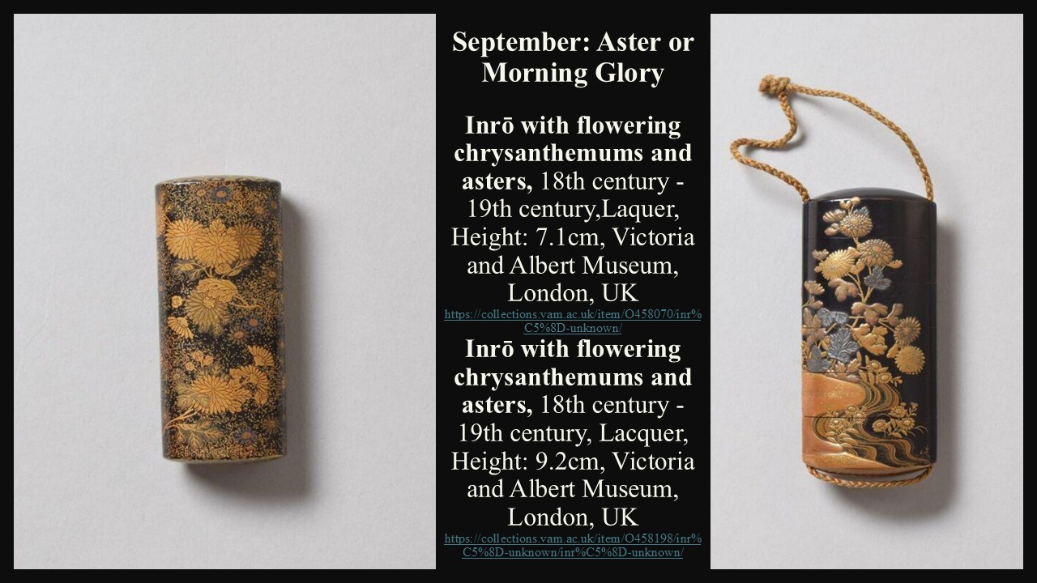
Student Activities
that combine looking, interpreting, making and connecting art with the seasons.

1. 🌸 A Season in the Palm of Your Hand
Focus: Art + symbolism + observation
Ask students to choose one season and create a miniature artwork inspired by it. Like the Japanese inrō, their design should communicate the season through flowers, colours, plants, animals or objects.
Students should:
- Choose 3–4 seasonal symbols.
- Explain what each symbol represents.
- Design a small “inrō-sized” composition.
- Give their artwork a title.
Discussion question:
If you could preserve one season in a small object, what would you choose to include—and why?

2. 🎨 Look Closely: Become an Art Detective
Focus: Visual analysis
Show students one of the inrōs without initially giving them any information about it.
Ask them to investigate the object as art detectives:
- What can you see?
- Which flowers can you identify?
- What colours and materials are used?
- How has the artist created a sense of depth?
- Where does your eye travel first?
- What might the decoration tell us about the object's owner?
Then reveal the historical information and ask:
Did your interpretation change once you knew what an inrō was?
This is an excellent activity for developing close looking and evidence-based interpretation.

3. 🌼 The Language of Flowers
Focus: Symbolism + cross-cultural comparison
Students investigate the meaning of Asters and Chrysanthemums in Japanese culture and compare them with flowers that have symbolic meanings in their own culture.
Create a simple classroom chart:
Flower | Culture | Meaning/Symbolism | Where We See It
Aster | Japan | Autumn, elegance... | Art, gardens...
Chrysanthemum | Japan | Longevity, renewal... | Art, celebrations...
Rose | ______ | ______ | ______
Olive branch | ______ | ______ | ______
Extension: Students choose one flower and find an artwork in which it appears. They explain how the artist uses the flower to communicate an idea.

4. 🍂 Mono no Aware: Beauty That Does Not Last
Focus: Japanese aesthetics + personal response
Introduce mono no aware as the awareness that beautiful things are especially moving because they are temporary.
Then ask students to think of something beautiful that changes or disappears:
- autumn leaves
- a sunset
- flowers
- childhood
- a particular place
- a family tradition
- a special moment
Students create a small drawing, photograph, collage or short piece of writing inspired by their chosen subject.
Key question:
Does something become more beautiful because we know it will not last?
This could lead to a particularly interesting classroom discussion about beauty, memory and time.

