The Minoan Swing: A 3,500-Year-Old Moment of Joy at Heraklion Museum

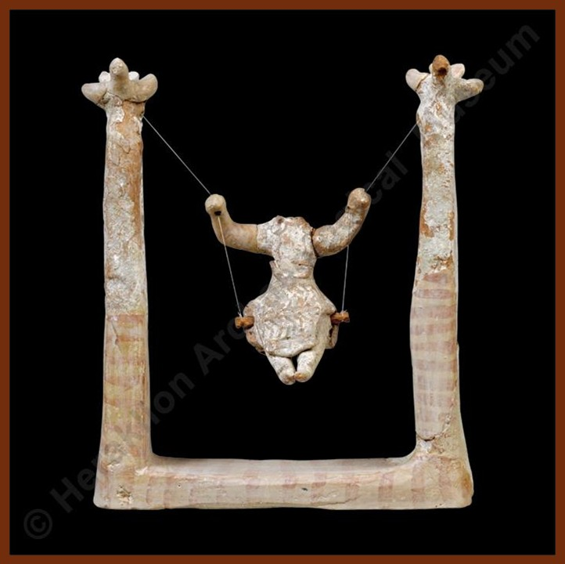
Clay model of swinging female figure ("The Swing"), Neopalatial period, 1700-1450 BC, Clay, Height: 15.5 cm, Height of female figurine: 6.3 cm, Heraklion Archaeological Museum, Crete, Greece
https://heraklionmuseum.gr/en/collections/#collections

What Were They Thinking? Creative Writing in Character
Students imagine they are the Minoan artist who created The Swing. They write a short first-person journal entry (one paragraph) describing why they made it, who it was for, and what they hoped people would feel when they saw it. This encourages empathy across time and helps students grapple with the idea that ancient people had rich inner lives, even if we can't read their words.
Museum Label Challenge
Show students a photo of The Swing and ask them to write a 50-word museum label for it — the kind you'd read on a small card beside the display case. They must include: what it is, how old it is, where it's from, and one thing that makes it significant. Compare labels as a class and discuss which details different students chose to prioritize and why.

