What a Clay Bowl with a Cheetah Tells Us About the Byzantine World

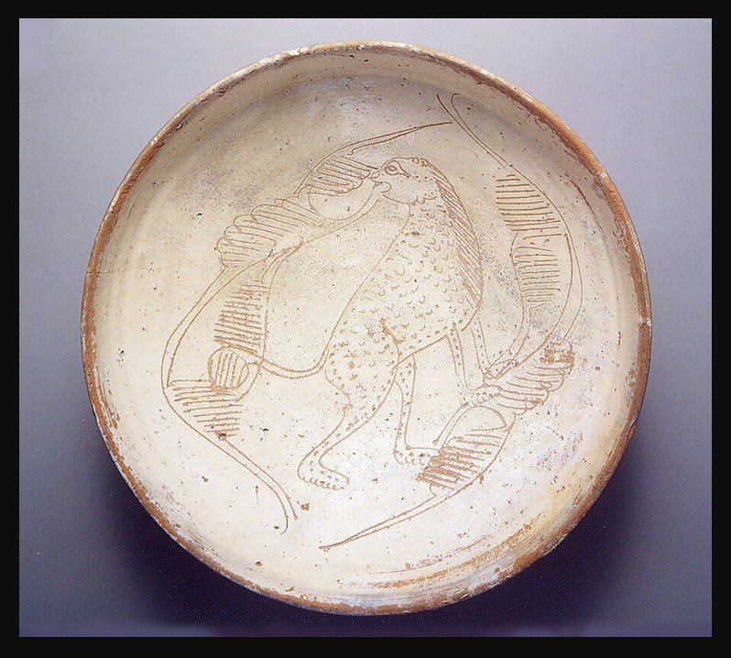
Byzantine Bowl with Cheetah, 11th–13th century, Engraved slipware, 9.8x25.5 cm, the MET, NY, USA
https://www.metmuseum.org/art/collection/search/465951
Introduction
In the Byzantine Empire, artists decorated everyday objects like bowls and plates using a technique called sgraffito. Potters scratched designs into clay to create images of animals, patterns, and symbols. These images were not just decoration — they often represented power, wealth, status, or important cultural ideas.
One Byzantine bowl featured a cheetah, an animal connected to imperial hunting and aristocratic prestige.
Today, symbols still communicate ideas about identity, power, and culture. In this activity, you will design your own Byzantine-inspired bowl using a modern symbol or animal.
1. Artifact Detective Activity
Ask students to imagine they are archaeologists discovering the bowl for the first time. In small groups, they examine the description and answer questions such as:
- What materials was the bowl made from?
- How was it decorated?
- Why might someone choose a cheetah as the design?
- What can this object tell us about daily life in Byzantium?
Students then create a short “museum label” for the object, explaining its importance in 3–5 sentences.

2. Design Your Own Byzantine Bowl
Students create their own paper “sgraffito” bowl designs inspired by Byzantine art.
Instructions:
- Draw a bowl template on paper.
- Choose an animal or symbol that represents power, identity, or status today.
- Use patterns and simple colours similar to Byzantine pottery.
- Write a short paragraph explaining why they chose their symbol and what it says about modern culture.
This activity connects art, symbolism, and historical interpretation.

3. Trade Routes and Cultural Exchange Map
Using a map of the Mediterranean, students trace possible trade routes between the Byzantine Empire and the Islamic world.
Students identify:
- Major seas and cities
- Trade goods that may have travelled
- How ideas and artistic techniques spread between cultures
Extension question:
“How does this challenge the idea that civilizations were completely separate from one another?”
Students can present their findings as a mini poster or digital slide.

4. Dinner Table Conversations Role-Play
Students work in groups and imagine they are guests at a Byzantine banquet where the cheetah bowl is being used.
Each student takes on a role:
- Merchant
- Noble
- Soldier
- Craftsperson
- Emperor’s servant
They create and perform a short conversation discussing:
- Hunting and status
- Trade and luxury goods
- The meaning of the cheetah symbol
- Everyday life in Byzantium
This helps students connect historical objects to real human experiences and social relationships.

