Nikos Hadjikyriakos-Ghikas
Interior with Woman and Mirror

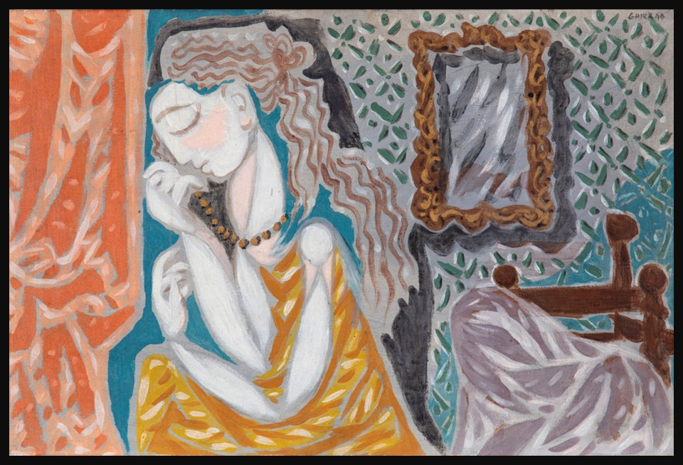
Nikos Hadjikyriakos-Ghikas, Greek, 1906-1994
Interior with Woman and Mirror, 1940, oil on canvas, 40 x 60 cm, Private Collection
https://www.bonhams.com/auction/31745/lot/34/nikos-hadjikyriakos-ghika-1906-1994-femme-dans-un-interieur-avec-miroir/

🧭 Step 1: First Impressions (Look & Describe)
Take 1–2 minutes to look carefully at the artwork.
- What is the first thing you notice?
- What colours dominate the composition?
- How would you describe the mood of the painting in 3 words?
✏️ Write your answers: …………………………………………………………………………………………

…………………………………………………………………………………………

…………………………………………………………………………………………
🪞 Step 2: The Woman & the Mirror
Ghikas places a woman in front of a mirror.
- What do you think the mirror shows us?
- Does the reflection look identical, different, or symbolic?
- What might the mirror represent (e.g. identity, beauty, thought, duality)?
✏️ Short answer:
…………………………………………………………………………………………

…………………………………………………………………………………………

…………………………………………………………………………………………
🧠 Step 3: Influence Detective – Paris & Picasso
Ghikas was influenced by modern artists such as Picasso.
Compare mentally or visually:
- What similarities can you imagine between Ghikas’ figure and Picasso’s Le Rêve?
- Why might an artist repeat the image of a sleeping or dreaming woman?
✏️ Think & respond:
…………………………………………………………………………………………

…………………………………………………………………………………………

…………………………………………………………………………………………
🧩 Step 4: Geometry vs Emotion
Look at the structure of the painting.
- Do you see more geometric shapes or organic forms?
- How does Ghika balance structure (order) and feeling (emotion)?
✏️ Write your thoughts:
…………………………………………………………………………………………

…………………………………………………………………………………………

…………………………………………………………………………………………
🌍 Step 5: Two Worlds in One Painting
Ghika worked between Paris and Greece.
- What elements feel “Parisian modernist”?
- What elements might feel “Greek” or Mediterranean?
✏️ Reflection:
…………………………………………………………………………………………

…………………………………………………………………………………………

…………………………………………………………………………………………
✍️ Step 6: Creative Response (Choose ONE)
Option A – Writing
Write a short paragraph:
“If I stepped inside this painting, I would…”
…………………………………………………………………………………………

…………………………………………………………………………………………

…………………………………………………………………………………………

