Living Statues: The Four Seasons
(Grade 1–2 Worksheet)

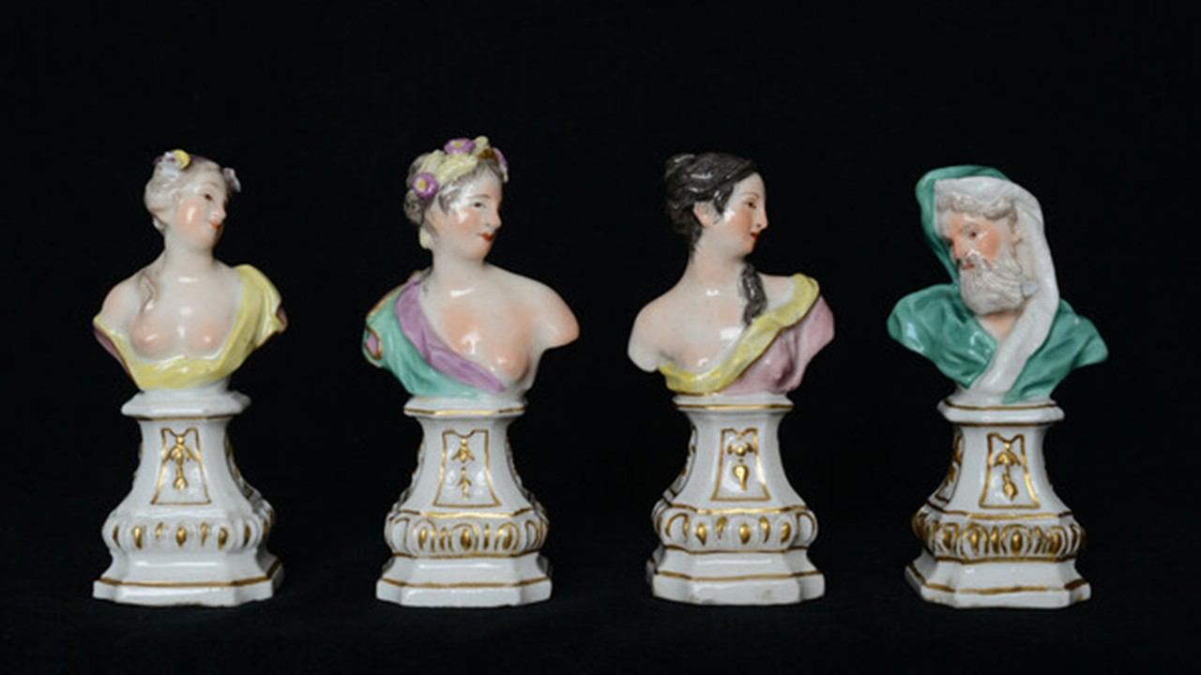
Meissen Workshop
Personification of the Four Seasons, circa 1755, Hard Paste Polychrome Porcelain, Musei Capitolini, Pinacoteca Capitolina Cini, Rome, Italy https://www.lifo.gr/culture/eikastika/noimata-i-nea-ekthesi-sto-moyseio-tis-akropolis

🌿 What are we learning?
We will learn how artists show the Four Seasons using our bodies, like statues!
🎯 Our Goal
I can show a season using my body and guess other seasons by looking carefully.

🧊 Step 1: Look and Think
Your teacher will show pictures of the Four Seasons.
👉 Circle what you notice:
- 🌸 Flowers
- ☀️ Sun
- 🍂 Leaves
- ❄️ Snow
- 🧥 Clothes (light / warm)
- 😊 Feelings (happy / cold / sleepy)

👥 Step 2: Make Your Group
Work with 2–4 classmates.
👉 Choose ONE season:
☐ Spring
☐ Summer
☐ Autumn
☐ Winter

🎭 Step 3: Create Your Statue
Together, make a frozen statue using your bodies.
Think about:
- What is the weather like?
- How does your body show the season?
- What face will you make?
👉 Practice and FREEZE!

👀 Step 4: Guess the Season
Watch other groups.
👉 Write or say your answer:
I think this is …………………………………………………………………………
Why? I saw:
☐ Movements
☐ Facial expression
☐ Body shape
My idea: ………………………………………………………………………………...

✏️ Step 5: Draw Your Statue
Draw your group’s statue:
🖍️
(Use space below)

……………………………………………………………………………………….…

..…………………………………………………………………………………………

…………………………………………..………………………………………………

💬 Step 6: Think About It
Circle your answer:
I worked well with my group:
😊 Yes 😐 A little 🙁 Not yet
My favorite season today was: …………………………………………………………

Because …………………………………………………………………………………

⭐ Great Job! You became a living artwork!

