Adam and the Animals: Imagining Paradise
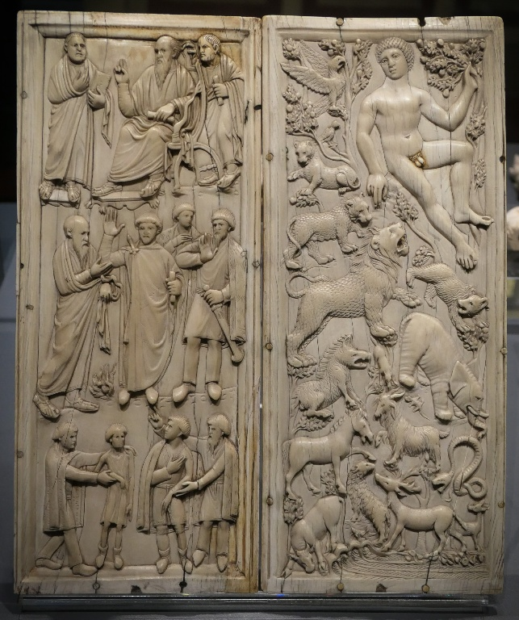
Diptych with scenes from the life of St. Paul and Adam in the Earthly Paradise, 4th to 5th century AD, Ivory, The Bargello Museums - National Museum of Bargello, Florence, Italy – Photo Credit: Marya Stamatiadi, 2025

Student Activity (Secondary Level)
Using the ivory diptych “St. Paul and Adam in the Earthly Paradise” from the Bargello Museum, students explore how the figure of Adam is used to represent an ideal world—and what the animals reveal about it.
Learning Objectives
- Develop close visual observation skills
- Understand symbolic meaning in early Christian art
- Reflect on how “paradise” is imagined and communicated
Step 1: First Impressions (5 minutes)
Display the Bargello Diptych – Discuss only the Adam panel.
Ask students:
- What is Adam doing?
- How would you describe his posture (relaxed, powerful, passive)?
- What is the overall mood of the scene?
Quick write (2–3 sentences):
“Is this what you imagine Paradise to look like? Why or why not?”
Step 2: Observing the Animals (10 minutes)
Students work individually or in pairs.
Task:
- Identify at least 5 animals
- Note where they are placed (close to Adam, above, below, surrounding him)
- Describe their behavior (calm, alert, interacting, still)
Guiding question:
Do the animals seem to obey Adam—or simply coexist with him?
Step 3: Interpreting Adam’s Role (10–15 minutes)
Provide a short context:
Early Christian writers like Ambrose described Adam as living in perfect harmony with nature before the Fall.
Group discussion:
- What kind of figure is Adam here—a ruler, a caretaker, or something else?
- Why are the animals peaceful? What does that suggest about Adam?
- Does this image show power, harmony, or control?
Encourage students to support their answers with visual evidence.

