Saving Andromeda: What’s the Story?

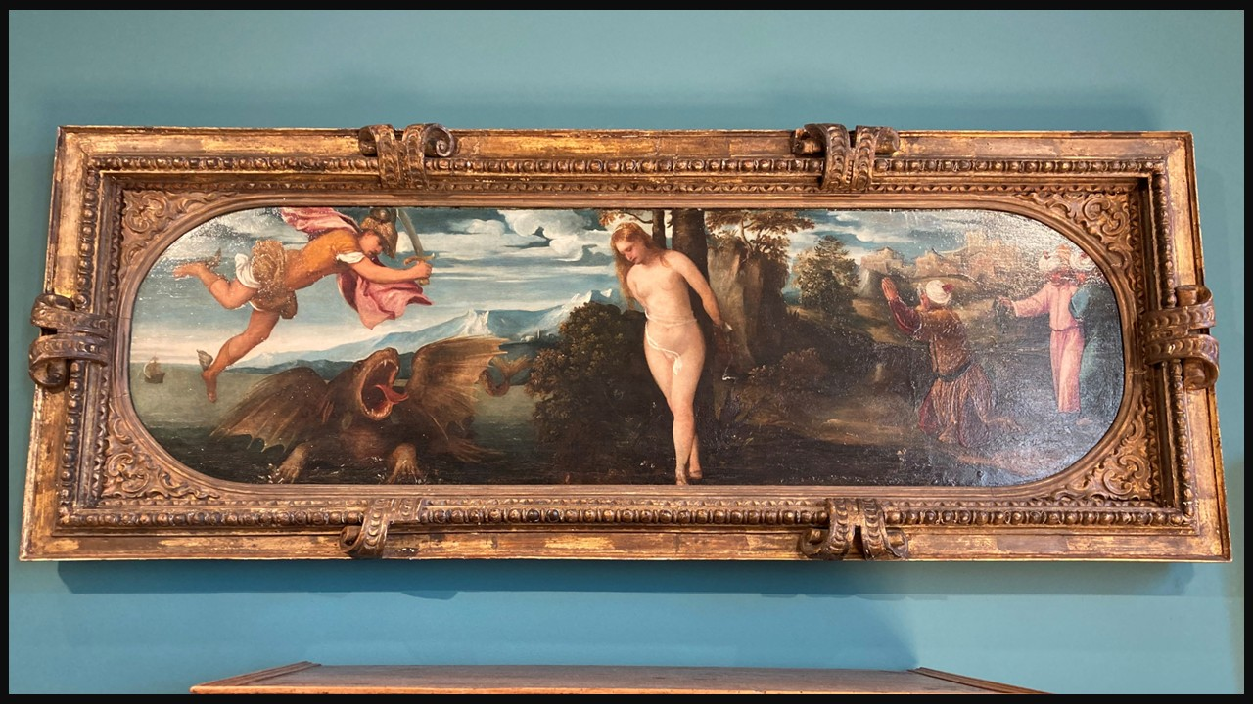
Bonifazio de' Pitati, 1487-1553
Perseus freeing Andromeda, 1543, Oil on Panel, Palazzo Maffei, Verona, Italy – Photo Credit: Amalia Spiliakou, September, 2025

Student Activity (Grade 6): A Hero, A Princess, A Story
Objective: Students understand how a myth about Perseus and Andromeda is told through art and what it meant to people in the past.

👀 Step 1: Look Closely (5 minutes)
Show the painting Perseus Freeing Andromeda and ask: 1. What is happening in this picture? 2. Who do you think the main characters are? 3. How does Andromeda feel? How can you tell?
👉 Tip: Encourage simple observations, no right or wrong answers.
📖 Step 2: Hear the Story (5 minutes)
Tell students the myth in simple terms and ask: What part of the story is the most exciting?
💡 Step 3: What Does It Mean? (7 minutes)
Explain simplyhow in the Renaissance, this painting might have been on a wedding chest (a cassone), and ask: 1. Why would people choose this story for a wedding? 2. What kind of person is Perseus? 3. What kind of person is Andromeda?
👉 Guide them to ideas like: brave, kind, patient, caring.
✏️ Step 4: Create Your Own Story (10 minutes)
Finish the sentence: This story shows that a good friend or partner should be…
🌟 Wrap-Up (2 minutes)
Ask students: 1. Do we still tell stories like this today? (movies, superheroes?) 2. Can you think of a modern “Perseus”?

