A Face Between Two Empires — Constantine in Marble
Name and Date ……………………………………………..

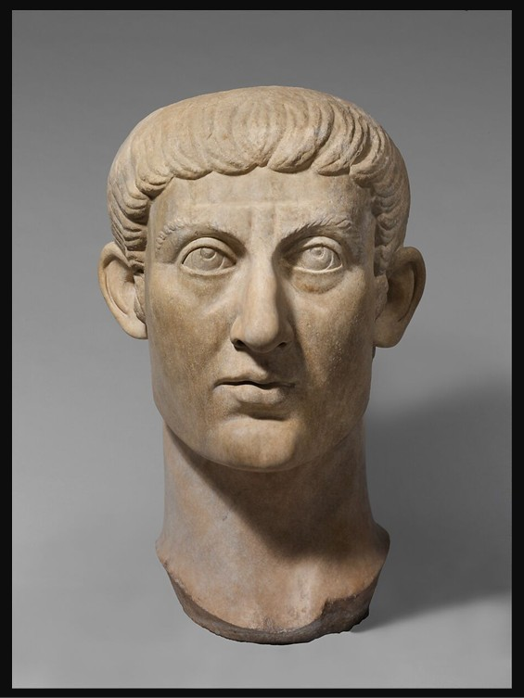
Marble portrait head of the Emperor Constantine I, ca. 325–370 AD, Marble, Height: 95.3 cm, the MET, NY, USA
https://www.metmuseum.org/art/collection/search/252884

Learning Focus
In this lesson, you will explore how the marble portrait of Constantine the Great communicates power, identity, and cultural change in the Roman world. You will analyse art as historical evidence and consider how images shape political meaning.

“Constantine’s Public Image: Then and Now” Writing Task
Students imagine they are Roman advisors tasked with shaping Constantine’s image.
They write:
A. Ancient Roman Official Description
Write a short formal description of Constantine’s portrait as if displayed in a Roman public space.
OR
B. Modern Social Media Post
Write a post introducing Constantine as emperor, highlighting his image and power.
Focus: How image-making supports political authority across time.

