Blossoms of May:
Johan Laurentz Jensen and the Poetry of Hawthorn

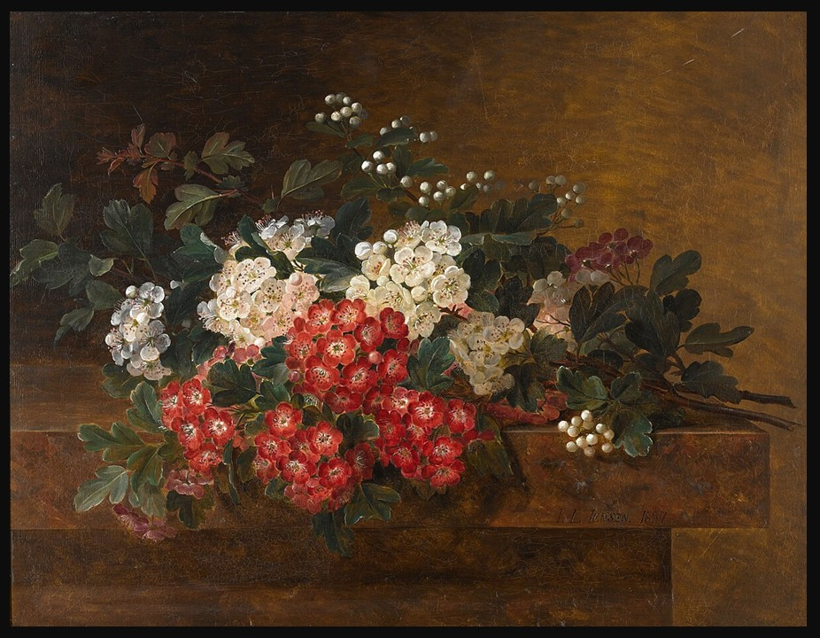
Johan Laurentz Jensen, Danish, 1800 – 1856
Still Life With Hawthorn Blossom, 1837, Oil on Panel, 29x37cm, Private Collection
https://www.sothebys.com/en/buy/auction/2020/european-british-art/still-life-with-hawthorn-blossom

Here is a Classroom-ready Student Activity based on the painting, designed for middle or high school learners. It combines observation, interpretation, and creative engagement.

1. Warm-Up: First Impressions (5–10 minutes)
Look carefully at the painting.
What is the first thing that catches your eye?
How would you describe the mood of the painting in one word?
What colors dominate the composition?
👉 Write 2–3 sentences describing your initial reaction.

2. Close Observation (10–15 minutes)
Now look more closely and answer:
What types of flowers do you see? (Hint: hawthorn blossoms are small, delicate, often white or pink.)
Where are the flowers placed? What is the setting or surface?
How does the artist use light and shadow?
Do the flowers look realistic? Why?
👉 Jensen was known for careful observation of nature and detailed rendering of plants
✏️ Sketch a small section of the painting (just a branch or cluster of flowers) focusing on detail.

3. Thinking Like an Art Historian (10 minutes)
Discuss or write short answers:
Why might an artist choose to paint flowers instead of people or landscapes?
What might these blossoms symbolize? (Think about spring, life, beauty, or time passing.)
The painting is very still and quiet—how does that affect how you feel as a viewer?
👉 Jensen’s works often combine beauty with symbolic meaning and a sense of transience

4. Spotlight on the Artwork (Context Activity)
This painting:
Was created in 1837
Is painted in oil on panel
Measures 29 × 37 cm
Was sold through Sotheby's in London
👉 Why do you think small, detailed paintings like this were popular in the 19th century?

5. Creative Response (15–20 minutes)
Choose one:
✏️ Option A: Draw Your Own Still Life
Create your own floral composition inspired by Jensen.Use real flowers OR invent your own arrangement
Focus on detail and careful observation
✍️ Option B: Write a Short Poem
Write 4–6 lines inspired by the painting.
Think about:
Spring
Fragility
Time passing

6. Reflection (Exit Task)
Complete the sentence:
👉 “This painting shows me that nature is…”
(Write 2–3 thoughtful sentences.)

