Fra Angelico, Fresco in Cell 42
Convent of San Marco, Florence
Visual Discovery Worksheet

Name:
Date:
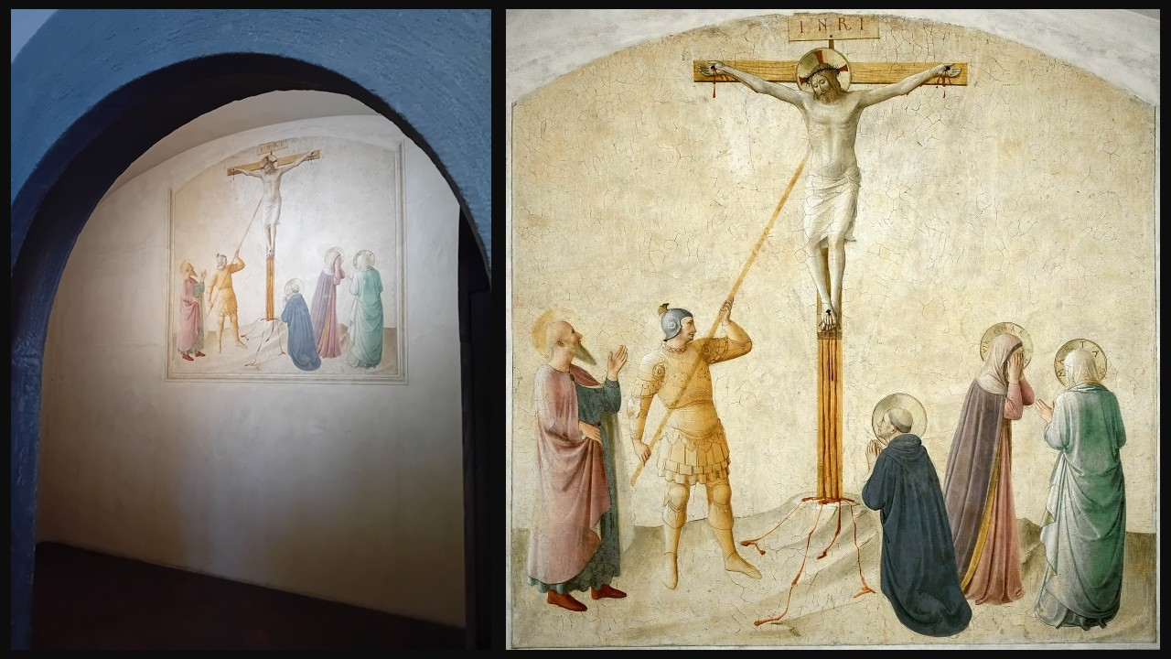
Fra Beato Angelico, 1395-1455
Crucifixion with the Virgin Mary with Martha, and Saints Mark, Dominic and Longino, 1440-1442, Fresco, Convent of San Marco, Cell 42, Florence, Tuscany, Italy
Photo Credits - Left: Petros Dimitrakopoulos, 2025, Right: https://gallerix.org/storeroom/217683978/N/8229/

Step 1: Silent Looking (5–7 minutes)
Look carefully at the fresco without speaking. Let your eyes move slowly across the whole image before focusing on small details.

Step 2: What Do You NOTICE?
List 5 specific things you see. These should be observations, not interpretations.

(Think about: colors, light, gestures, facial expressions, clothing, space, objects, architecture, mood.)
Step 3: What Do You WONDER?
Write 3 questions the painting makes you think about.

(There are no wrong questions — focus on what genuinely puzzles or interests you.)

Step 4: What Makes You CURIOUS?
Write 1 thing you would like to learn more about after seeing this fresco.

Step 5: Group Discussion
Be ready to share:
- One thing you noticed that others might have missed
- One question you’re most interested in exploring
Discussion Prompt:
How do your observations help you understand the mood, meaning, or purpose of this fresco inside a monk’s cell?
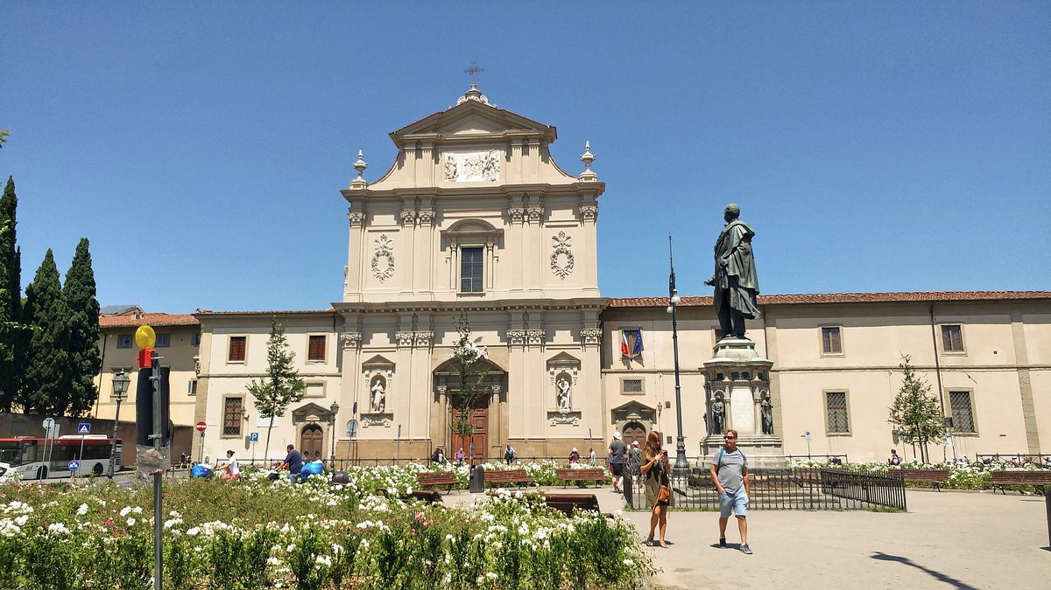
Piazza San Marco, Florence, Italy
https://www.tripadvisor.com/Attraction_Review-g187895-d3450755-Reviews-Piazza_San_Marco-Florence_Tuscany.html

