List of Student Activities on the Greek Revolution of 1821 prepared by Greek Museums and Foundations
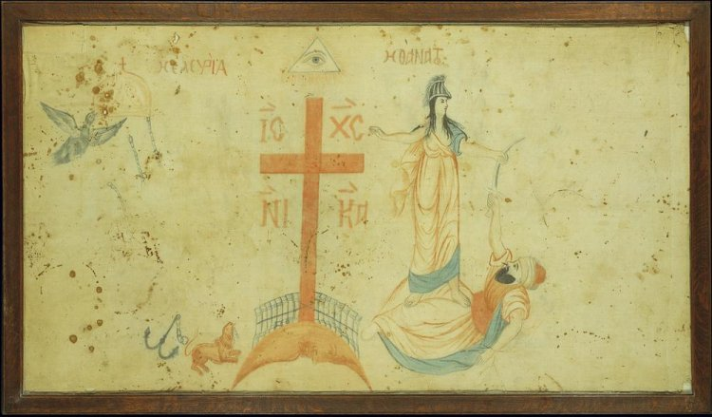
“Flag with the representation of Greece in the form of the goddess Athena and the inscription Ή ELEJETHIA Ή DEATH Initially it belonged to Theodoros Kolokotronis, who offered it to Konstantinos Dragonas, a member of the Zakynthos Committee, who served the Struggle, facilitating the contacts of the Greeks with the British administration in the Ionian Islands.” 0.92x1.50 m, Benaki Museum https://www.benaki.org/index.php?option=com_collectionitems&view=collectionitem&id=104025&Itemid=&lang=el
The Museum of School Life and Education has developed a new Educational Program for 1821 (in Greek). https://ekedisi.gr/ekpaideytika-programmata-gia-to-1821/
The Greek Revolution for Primary School students is an educational program for the Greek Revolution at the Athens War Museum (in Greek)! https://www.lodestonefellows.com/%CE%B5%CE%BA%CF%80%CE%B1%CE%B9%CE%B4%CE%B5%CF%85%CF%84%CE%B9%CE%BA%CF%8C-%CF%80%CF%81%CF%8C%CE%B3%CF%81%CE%B1%CE%BC%CE%BC%CE%B1-%CE%B5%CF%80%CE%B1%CE%BD%CE%AC%CF%83%CF%84%CE%B1%CF%83%CE%B7-1821/
From the Onassis Foundation… Illustrator and author Lida Varvarousi holds the keys to unlock myth and symbols Rigas’s famous map (in Greek)… https://www.onassis.org/el/whats-on/paintelling-travelling-with-the-symbols-and-myths-of-rigas-charta/digital-material-a-journey-with-the-myths-and-symbols-of-rigas-charta-through-a-childrens-book
We visit the Benaki Museum and explore its Educational Program and its BenaKids OnLine Activities (in Greek)… https://www.benaki.org/index.php?option=com_educations&view=education&id=1005091&Itemid=165&lang=el
The Stavros Niarchos Foundation Cultural Center presents a series of Events under the general title Faces of a Hero… https://2021.snfcc.org/en/

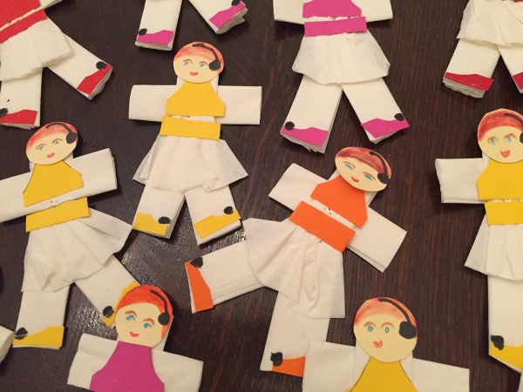
Student Art Activity… Our ‘Foustaneloforoi’ ready to Parade!

