Seeing the Divine — Fragment, Function, and Meaning

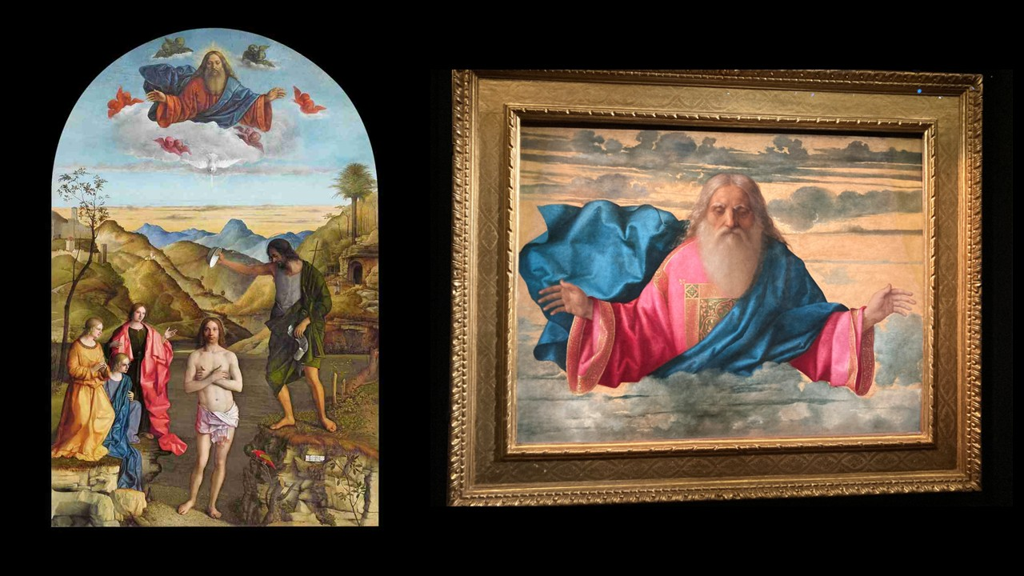
Giovanni Bellini, 1434-1516
Garzadori Altar with The Baptism of Christ, 1500-1502, Tempera on board, 400cm x 263cm, Chiesa di Santa Corona, Vicenza, Italy https://www.facebook.com/groups/162243897516549/posts/1715539035520353/
God the Father, 1505-1510, Oil on Wood, 102x132 cm, Palazzo Mosca-Musei Civici, Pesaro, Italy – Photo Credit: Amalia Spiliakou, March 2023

Activity Overview
Students explore how context and function shape meaning by analyzing Bellini’s painting as both an independent image and as the fragment of a lost altarpiece. The activity encourages visual analysis, historical reasoning, and interpretive writing.

Step 1 – Slow Looking (5–7 minutes)
Ask students to look silently at the image.
Guiding prompts:
- What is the first emotion this figure communicates?
- How does Bellini use gesture and gaze to engage the viewer?
- Which elements feel human, and which feel transcendent?
Students write down 5 descriptive words, avoiding interpretation at first.

Step 2 – Formal Analysis (Small Groups, 10 minutes)
In groups, students focus on one visual element:
- Color (blue mantle, red garment)
- Light and atmosphere
- Composition and symmetry
- Scale and framing
Each group answers: How does this element contribute to the tone of the image?
Groups briefly report back.

Step 3 – Contextual Shift: Fragment of an Altarpiece (10 minutes)
Introduce the key contextual information:
- The panel is likely the upper fragment of a lost altarpiece
- Compare it conceptually to Bellini’s Baptism of Christ altarpiece in Vicenza
Discussion questions:
- How might this image have functioned above another sacred scene?
- How does its meaning change when imagined as part of a larger structure?
Students sketch (very roughly) what they imagine the lower panel may have depicted.

Step 4 – Interpretive Writing (10 minutes)
Individual task:
Prompt: How does Bellini’s restrained depiction of God the Father communicate authority without drama?
Students write one short paragraph using:
- at least one visual detail
- at least one contextual reference

Learning Outcomes
By the end of the activity, students will:
- Practice close visual analysis
- Understand how altarpiece function shapes meaning
- Recognize Bellini’s late-style restraint
- Connect form, context, and devotional purpose

