Measuring The World
Ktisis and the Roman Foot Rule

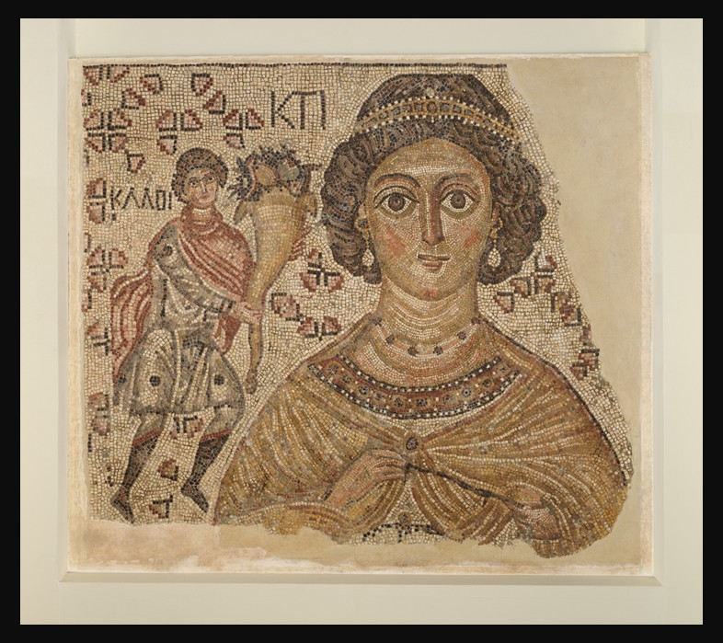
Fragment of a Floor Mosaic with a Personification of Ktisis, 500–550, with modern restoration, Marble and Glass, 151.1 x 199.7 x 2.5 cm, the MET, NY, USA
https://www.metmuseum.org/art/collection/search/469960

Learning Objectives
By completing this activity, students will:
- Understand the function of Roman measuring tools and their symbolic meaning
- Explore how objects can communicate abstract ideas such as order, stability, and civic identity
- Connect artistic imagery with architectural practice in Late Antiquity

Part 1 – Close Looking (Observation)
Look carefully at the figure of Ktisis in the mosaic.
- Describe the object she holds in her hand. What is its shape and material?
- Where is it positioned in relation to her body? Why do you think the artist wanted it to be clearly visible?
- How does this object compare in importance to her clothing, jewelry, or facial expression?
Teacher note: The object is a Roman copper foot rule, a tool used to measure length. Long ago, people measured short distances using their own feet, from heel to toe. But because everyone’s feet were different sizes, the Romans needed a better system. As they built roads, buildings, and cities, they decided to use one standard foot based on the emperor’s foot. They made copper rulers to match this length. Each ruler was divided into twelve equal parts, just like we have twelve inches in one foot today.

Part 2 – Function and Meaning (Context)
In Roman and Late Antique society, measuring tools were essential for building roads, houses, baths, churches, and civic spaces.
- Why would accurate measurement have been important in Roman architecture?
- How might a measuring tool symbolize ideas such as order, fairness, or stability?
- Why do you think a personification like Ktisis—associated with foundation and creation—would hold a foot rule instead of a religious or mythological object?

Part 3 – Art and Architecture (Interpretation)
This mosaic originally decorated a floor, meaning viewers walked across it every day.
- How does knowing the mosaic was underfoot change the way you think about the measuring tool?
- What message might the patron of the building have wanted to communicate by showing Ktisis holding a tool used by architects and builders?

Part 4 – Compare and Connect (Discussion or Writing)
Choose one prompt:
- Compare the Roman foot rule to a modern measuring tool (ruler, tape measure, laser level). What values do these tools represent today?
- Imagine this mosaic in a newly built church or villa. How would the image of Ktisis reassure visitors or residents?
Write a short paragraph (5–7 sentences).

Extension Activity (Optional)
Design Your Own Personification
Create a modern personification of Foundation or Order. Draw the figure and choose one object they would hold today. Write 2–3 sentences explaining your choice.

Key Takeaway
In Late Roman and Early Christian art, everyday objects like measuring tools were not merely practical—they carried powerful symbolic meaning. By placing a foot rule in the hand of Ktisis, the mosaic connects architecture, civic order, and prosperity into a single enduring image.

