Antonio Badile’s Madonna and Child: An Intimate Window into Veronese Quattrocento Art

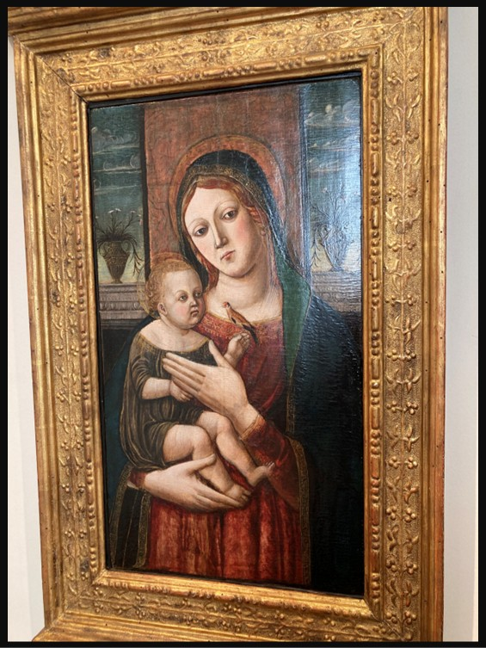
Antonio Badile, 1424 - 1512
Madonna and Child, end of 15th century, Tempera on panel, Palazzo Maffei, Verona, Italy – Photo Credit: Amalia Spiliakou, September 2025

Student Worksheet: Antonio Badile, Madonna and Child (Late 15th Century)

Part 1 — Close Looking (10 minutes)
Spend 2–3 minutes observing the painting without writing. Then answer:
- List five details you noticed only after slow looking:
a.
b.
c.
d.
e.

- Choose one detail from your list.
Why do you think the artist includes it?
(Think: emotion, symbolism, setting, realism.)

Part 2 — Symbolism & Iconography (10–15 minutes)
Match each symbol in the painting with its likely meaning. You may look up brief definitions if needed.
A. The Goldfinch
□ Purity □ Christ’s future Passion □ Royal authority
Correct meaning: ___________________________

B. The Lilies
□ Mary’s purity □ Divine protection □ Earthly wealth
Correct meaning: ___________________________

C. The Transparent Veil
□ Mary’s humility
□ Christ’s divinity
□ Badile’s interest in naturalism
Correct meaning: ___________________________

D. The Landscape Windows
□ An escape scene
□ A reminder of the wider world beyond the holy figures
□ A stylistic habit with no meaning
Correct meaning: ___________________________

Part 3 — Gothic or Renaissance? (10 minutes)
Read the list of features. Decide whether each one reflects Gothic or Renaissance style.
- Elongated fingers and elegant hand gestures →

…………………………………………………………………………………………..

- More natural interaction between mother and child →

…………………………………………………………………………………………..

- Decorative emphasis on drapery folds →

…………………………………………………………………………………………..

- A believable interior space with landscape glimpses →

…………………………………………………………………………………………..

- Emotional realism in facial expressions →

…………………………………………………………………………………………..

Part 4 — Interpreting the Goldfinch (Short Writing Task, 5–7 sentences)
The goldfinch was a popular symbol in Renaissance images of the Christ Child.
Write 5–7 sentences explaining:
- what kind of bird it is,
- what it symbolized,
- why its presence adds emotional or theological depth to the painting.
Your response:

Part 5 — Curatorial Thinking: Write a Wall Label (120 words max)
Imagine this painting will appear in a museum exhibition about family, devotion, and Renaissance symbolism.
Write a concise museum wall label including:
- artist, title, date, medium
- 1 key symbolic detail
- 1–2 interpretive ideas
Your label:

Optional Extension — Creative Voice (for homework or enrichment)
Choose one of the following to write a short creative piece (100–150 words):
- A monologue from the perspective of the goldfinch
- A reflection from Mary
- A description of the room beyond the figures
- A letter from the original owner of this devotional painting

