Yayoi Kusama’s Infinity Mirrored Room – A Wish for Human Happiness Calling from Beyond the Universe
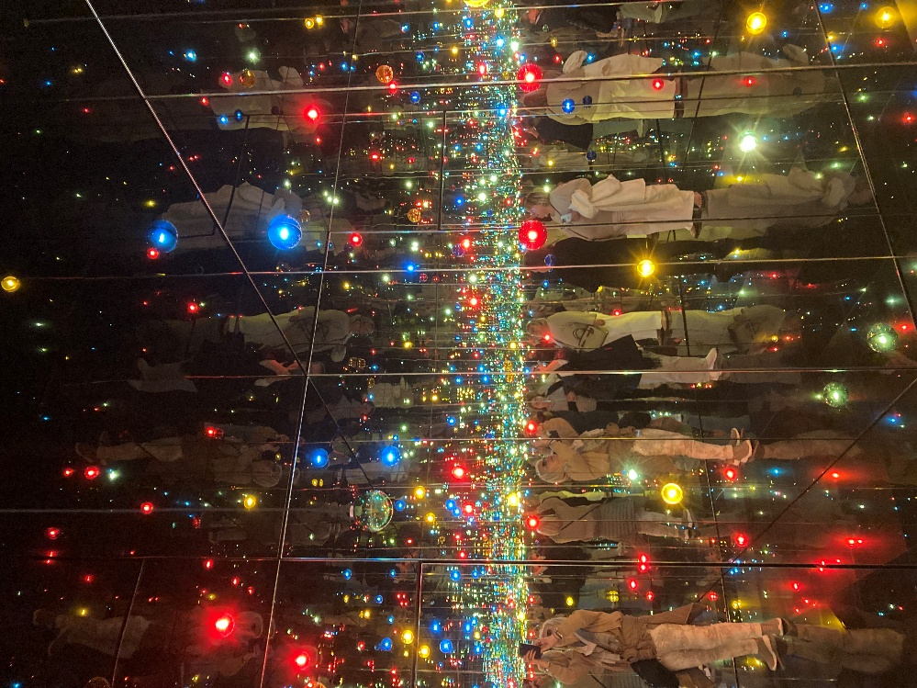
Yayoi Kusama, b. 1929
Infinity Mirrored Room – A Wish for Human Happiness Calling from Beyond the Universe, 2020, Mirrors, wood, LED lighting system, metal and acrylic panel
293.7 × 417 × 417 cm, Guggenheim, Bilbao, Spain – Photo Credit: Amalia Spiliakou, Spring 2024

Here is a hands-on, classroom-ready Student Activity inspired by Yayoi Kusama’s Infinity Mirrored Room – A Wish for Human Happiness Calling from Beyond the Universe (Guggenheim Bilbao). This activity includes objective, materials, steps, time, and quick assessment — ready to use or adapt by age.
Mini Infinity Boxes (Make a personal mirrored environment)
Objective: Explore repetition, reflection, and scale to evoke “infinity.”
Materials: Small cardboard box (shoe-box size), mirror acrylic sheets or mirrored paper (2–3 small pieces), LED tealight, colored cellophane, sequins/stickers, glue/tape, scissors.
Steps (30–45 min): Cut viewing hole in lid. Line two opposite inner walls with mirrored sheet/paper. Decorate remaining walls with dots/reflective materials; add colored cellophane over the light and place LED inside. Close, look through opening and sketch reaction.
Assessment: Students submit a 3–4 sentence artist statement: what feeling the box creates and how repetition/reflection changes perception.

