The Mycenaean Boat Fresco from Orchomenos: A Glimpse of Maritime Power

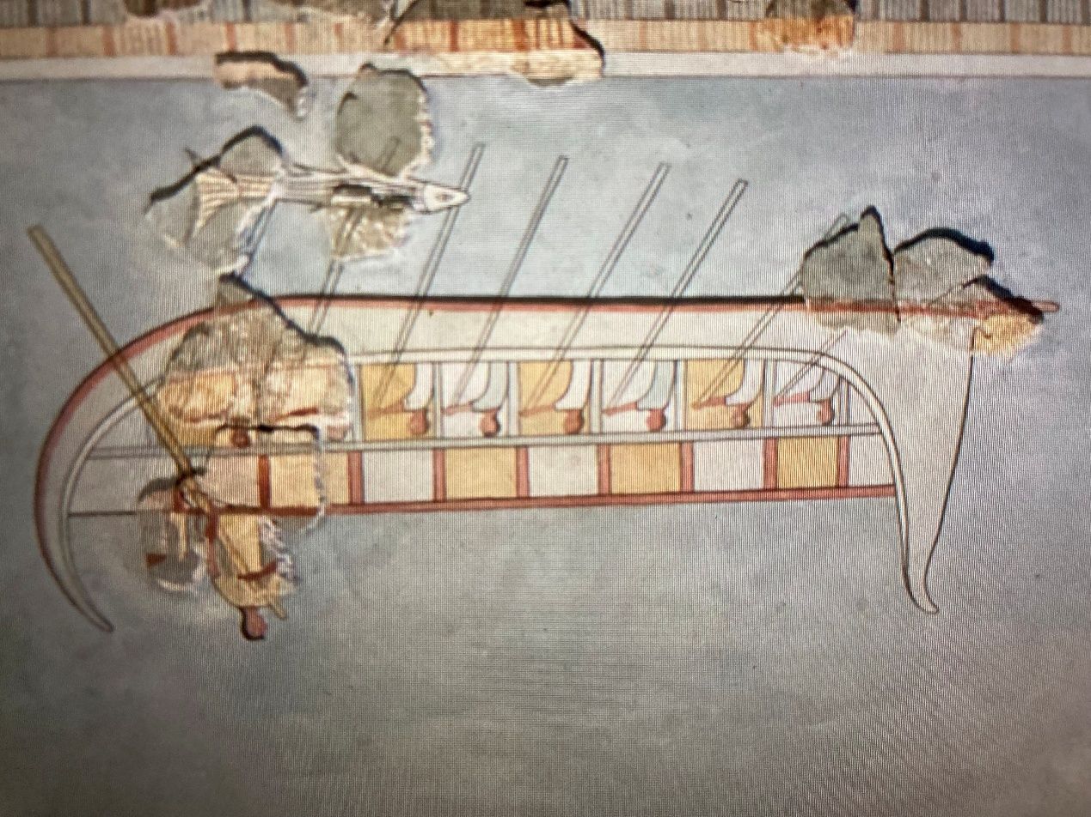
Wall Painting from the Mycenaean Palace of Boeotian Orchomenos, Late Bronze Age, 13th century BC, Archaeological Museum of Thebes, Greece

Activity 1: Story Afloat – Write & Perform a Sea Journey

Background: The Boat fresco may have shown a trading voyage or a mythic journey.
Your Task: Invent a short story based on the boat scene and perform it as a mini-play or tableau vivant.
Steps:
1. In your group, decide: Who is on the boat? Where are they going? Why?
2. Write a short script (2–3 minutes).
3. Perform your story for the class.
Story Planning:
Title: ____________________________
Setting: __________________________
Characters: _______________________
Plot (beginning, middle, end): ____________________________
Reflection: What inspired your story from the fresco details?

Activity 2: Map the Trade – Bronze Age Routes

Background: Mycenaean sailors traveled widely to trade goods such as pottery, metals, and oil.
Your Task: Use a map of the eastern Mediterranean to mark possible Mycenaean trade routes. Label what was traded and why.
Steps:
1. Identify Mycenae, Crete, Egypt, Cyprus, and Troy.
2. Draw routes between them.
3. Write 2–3 sentences explaining each route.
Reflection:
• What challenges might sailors have faced?
• What clues does the fresco give about their ships or journeys?

Activity 3: Conservation Detective – Preserve the Fresco!

Background: Frescoes can fade or flake after thousands of years. Conservators study damage and find ways to protect them.
Your Task: Act as an art conservator. Examine “damage reports” and propose a plan to preserve the fresco.
Scenario Card:
Problem: ____________________________
Possible cause: ______________________
Your solution: ________________________
Team Discussion Notes:
________________________________________
Reflection: Why is it important to preserve ancient art?

Activity 4: Museum Label & Mini Display

Background: Museum labels help visitors understand an artwork. They should be short, clear, and interesting!
Your Task: Write a 60–80 word label and design a small display for the Boat Fresco of Orchomenos.
Template:
Title: ___________________________
Date/Place: ______________________
Description (What do we see?): ___________________________
Why is it important?: ___________________________
Fun Fact or Question for Visitors: ___________________________
(Sketch your mini-display below:)

