IVLIA BELLA

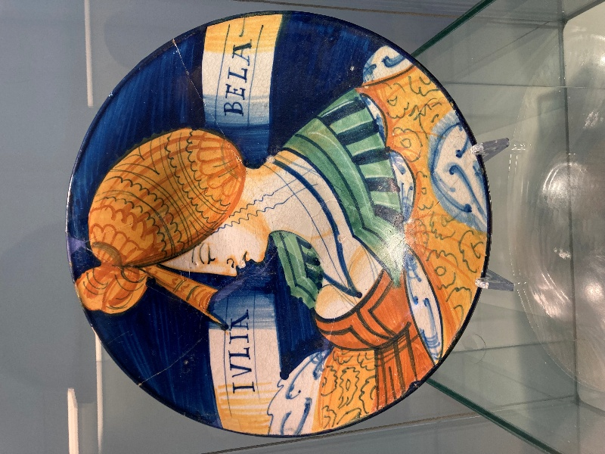
Iulia Bella plate, Faenza, end of 15th – beginning of 16th cent., Maiolica, Diameter: 28.2 cm, International Ceramics Museum in Faenza, Italy – Photo Credit: Amalia Spiliakou, April 2025

Here are three engaging Student Activities inspired by IVLIA BELLA, designed to combine creativity, historical understanding, and visual analysis:

- Portrait in Profile – Ceramic or Paper Design
Activity: Students create their own “bella donna” plate by drawing or painting a bust in profile, inspired by Renaissance fashion and hairstyles. They can use paper, clay, or even digital media. Encourage attention to clothing, inscriptions, and symbolic details.
Learning Outcome: Students explore portraiture, composition, and Renaissance aesthetics, while understanding how art conveyed social status and personal identity.
2. Renaissance Detective – Research and Storytelling
Activity: Students research the cultural and historical context of the Iulia Bella plate, including Faenza maiolica, Renaissance humanism, and marriage customs. They then write a short fictional diary entry or letter from the perspective of “Iulia Bella” or the patron who commissioned the plate.
Learning Outcome: Students develop historical empathy and learn how objects can tell stories about individuals and society.
3. Symbol and Inscription Analysis
Activity: Provide students with images of Renaissance plates and ask them to identify symbolic elements (e.g., dress, hairstyle, scrolls, inscriptions). They then present their interpretations of what these symbols might say about the person depicted or the patron’s intentions.
Learning Outcome: Students practice visual analysis and critical thinking, connecting visual details to broader social and cultural meanings.

