Exhausted Grace: Tired Salesgirl on Christmas Eve

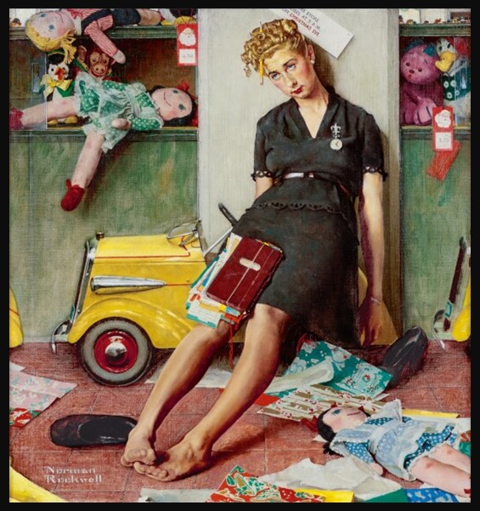
Norman Rockwell, American Artist, 1894-1978
Tired Salesgirl on Christmas Eve, 1947, Oil on Canvas, 77.2x71.8 cm, Private Collection

Here are five engaging student activities for Norman Rockwell’s “Tired Salesgirl on Christmas Eve”:

- Art Analysis Discussion – Have students observe the painting closely and discuss Rockwell’s use of light, color, and composition. Ask them what details convey the salesgirl’s exhaustion and the holiday atmosphere.
- Creative Writing Prompt – Students write a short diary entry or letter from the perspective of the salesgirl, reflecting on her long day, her thoughts about Christmas, and what she hopes for the holiday.
- Historical Context Research – Students research the 1940s American retail culture and women’s roles in the workforce, then present how Rockwell’s painting captures that moment in history.
- Visual Reinterpretation – Students create their own modern version of the painting, showing how a contemporary retail worker might feel on Christmas Eve today, using drawing, photography, or digital art.
- Emotion and Symbolism Chart – In pairs, students list the visual elements (props, facial expression, posture, background) and connect them to emotions or symbolic meanings that Rockwell may have intended.

