Fabulous Beasts I

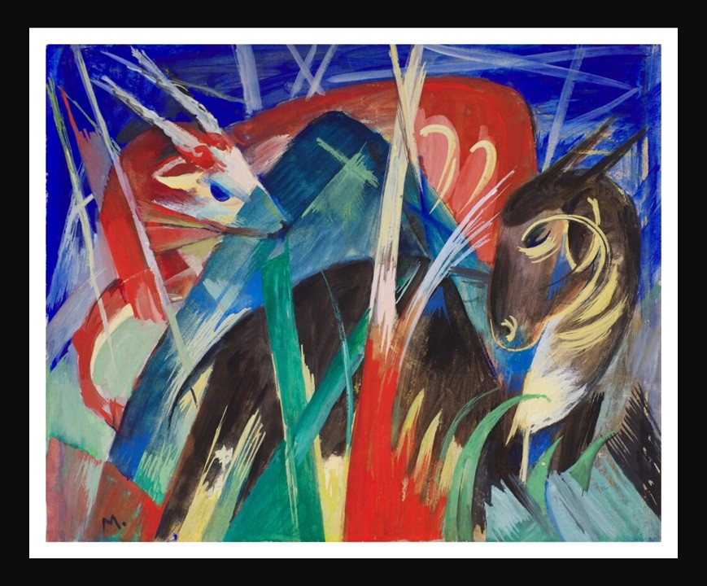

Franz Marc, German Artist, 1880 - 1916
Fabulous Beasts I (Composition of Animals I), 1913, tempera and gouache on paper, 25.5x31.5 cm, Private Collection
https://www.sothebys.com/en/buy/auction/2021/modern-evening-auction/fabeltiere-i-tierkomposition-i-fabulous-beasts-i

Here is an engaging Student Activity inspired by Franz Marc’s Fabulous Beasts I (Composition of Animals I), designed to connect students with his ideas about color, emotion, and spirituality in nature:

Color and Emotion Study: “Painting with Meaning”
Objective: To explore how Franz Marc used color symbolically to express spiritual ideas.
Activity: Students analyze Marc’s color choices (e.g., blue for spirituality, yellow for joy, red for violence) and then create their own small paintings or digital artworks of an animal using a limited color palette that represents specific emotions or concepts. Afterwards, they present their work and explain how their chosen colors convey mood and meaning.

