The Consular Diptych of Anicius Faustus Albinus Basilius

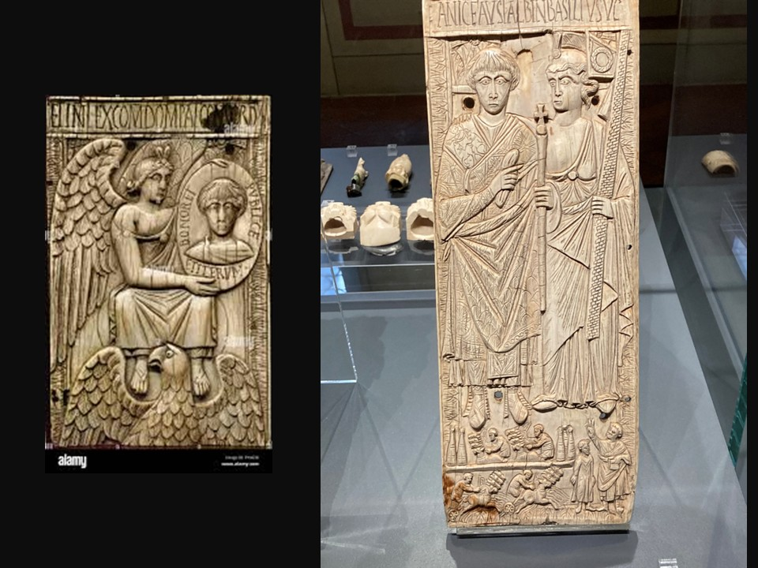
Consul Basilio with personification of Rome and chariot race, 541 – 541, Plaque of an Ivory Consular Diptych, 34.5x12.9 cm, National Museum of Bargello, Florence, Italy – Photo Credit: Amalia Spiliakou, April 2025
Ivory Angel from Bottega Romana, Fragment of a diptych valve. 6th Century Museum of Ancient Art in the Castello Sforzesco - Sforza Castle in Milan Italy
https://www.alamy.com/ivory-angel-from-bottega-romana-fragment-of-a-diptych-valve-6th-century-museum-of-ancient-art-in-the-castello-sforzesco-sforza-castle-in-milan-italy-image223703517.html

Comparative Analysis of Iconography and Style
Objective: Students will analyze and compare the artistic style and iconography of consular diptych from different Milan and Florence.

Activity:
1. Role-Playing as Roman Consuls
Objective: Students will engage in role-playing to understand the political and social significance of consuls in Late Antiquity.
Activity:
- Scenario Setup: Assign students roles as Roman consuls, senators, and citizens.
- Task: Students will reenact a consular inauguration ceremony, including the distribution of ivory diptychs as commemorative gifts.
- Discussion: After the role-play, discuss the symbolism of the diptychs and their role in reinforcing political alliances and social status.
Learning Outcomes:
- Understanding of Roman political structures and ceremonies.
- Insight into the use of art as a tool for political communication.

These activities aim to provide students with a comprehensive understanding of consular ivory diptychs, fostering both analytical and creative skills. If you need further resources or guidance on implementing these activities, feel free to ask!

