The Etruscan Tomb of Hunting and Fishing
Myth and Ritual Exploration Activity

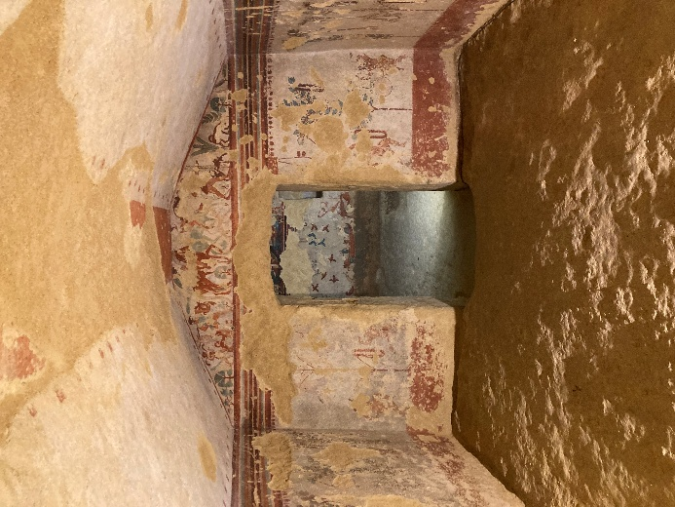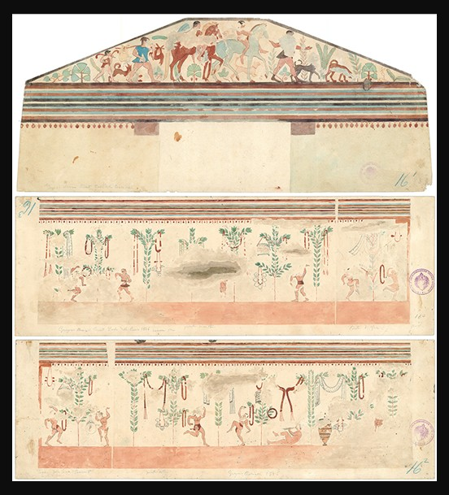

Etruscan Tomb of Hunting and Fishing, 520-510 BC, Necropoli dei Monterozzi, near Tarquinia, Lazio, Italy – Photo Credit: Amalia Spiliakou, April 2025
Gregorio Mariani, Tomba della Caccia e Pesca (prima stanza), D-DAI-ROM-A-A-VII-27-016/017/018 - © DAIR Archivio

Instructions: Research the Dionysian elements in the antechamber of the Tomb of Hunting and Fishing, including the satyrs, ritual dance, wreaths, ribbons, mirrors, and cistae. Explore how these motifs reflect Etruscan religious beliefs, funerary practices, and the influence of Greek mythology.

Guiding Questions:
- Who was Dionysus in Greek mythology, and what aspects of life or nature did he represent?
- How did the cult of Dionysus influence Etruscan religion and funerary practices?
- What do the dancing figures, satyrs, and ritual objects suggest about Etruscan beliefs regarding the afterlife?
- Why do you think scenes of celebration, ritual, or dance were included in a tomb?
- How might the combination of hunting scenes and Dionysian rituals reflect the Etruscans’ views of life, death, and the continuation of earthly pleasures?
- How do objects like wreaths, ribbons, mirrors, and cistae function symbolically in the frescoes?
- How might the frescoes reflect a connection between nature, fertility, and spiritual renewal?

