Comparing the Ivory Plaques of Empress Ariadne
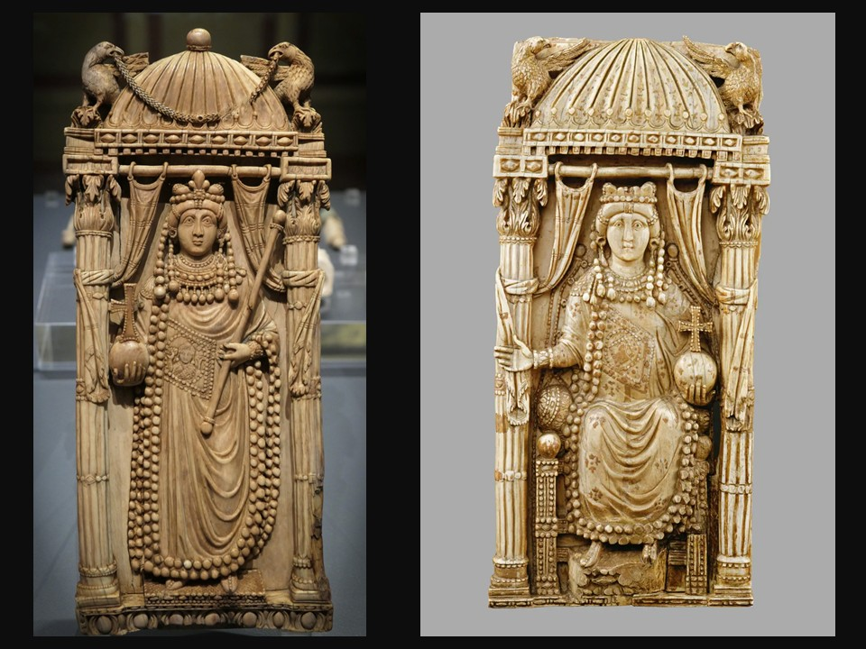

Empress Ariadne, around 500 AD, Ivory, Height: 36,5 cm, The Bargello Museum, Florence, Italy – Photo Credit: Marya Stamatiadi April 2025
Empress Ariadne, around 500 AD, Ivory, Height: 26,5 cm, Kunsthistorisches Museum, Vienna, Austria
https://www.khm.at/en/artworks/kaiserin-ariadne-71782-1

Part A – Careful Looking
- Observation:
  - What do you notice first in each plaque?
  - Describe the figure’s clothing, jewelry, and hairstyle.
  - How is the body positioned?
- Details:
  - What symbols or objects appear (e.g., crown, cross, scepter)?
  - Are there inscriptions or decorative patterns?
  - Which artistic details strike you as especially refined?

Part B – Comparison
- Similarities:
  - List three features that are common to both plaques.
- Differences:
  - List at least two features that differ between the Florence and Vienna plaques.
- Interpretation:
  - How do these similarities and differences shape your understanding of the Empress’s image?

Part C – Historical Context
- According to most scholars, these plaques represent Empress Ariadne (r. 474–515).
  - How does the imagery emphasize her authority and status?
  - What Christian elements can you identify, and what might they symbolize?
- Think about luxury art in Late Antiquity:
  - Why would ivory be chosen as the material?
  - How might these plaques have functioned within the Byzantine court?

Part D – Reflection & Presentation
- Prepare a short group presentation or poster comparing the two plaques.
- Include at least one visual (drawing, printed image, or diagram).
- Conclude with: “What do these works teach us about power, identity, and art in Early Byzantine society?”

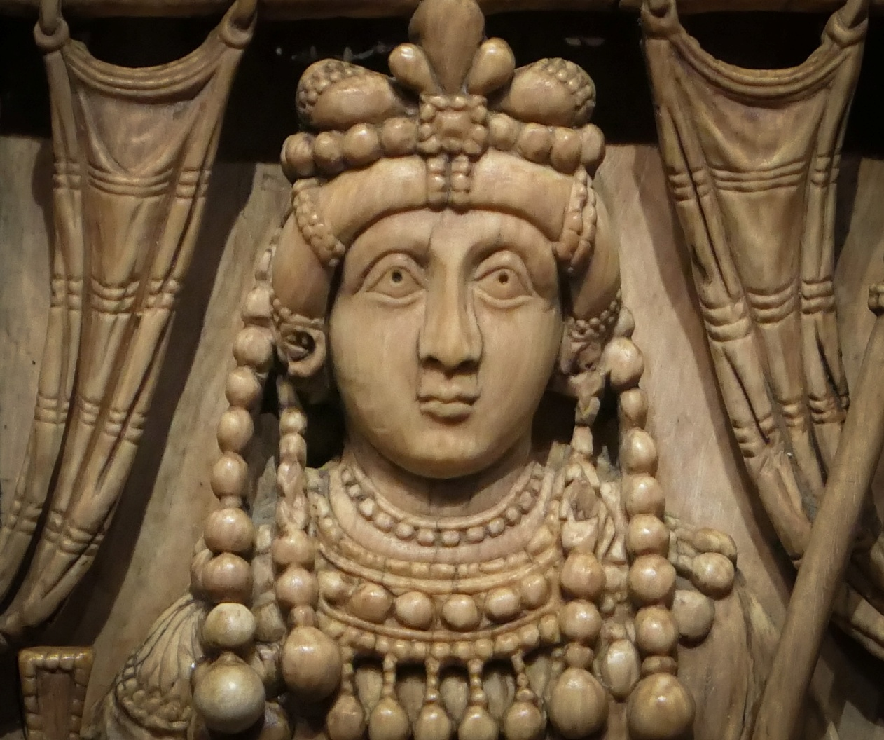

Empress Ariadne (detail), around 500 AD, Ivory, Height: 36,5 cm, The Bargello Museum, Florence, Italy – Photo Credit: Marya Stamatiadi April 2025

