Martial Reportage and Archaeological Revelation

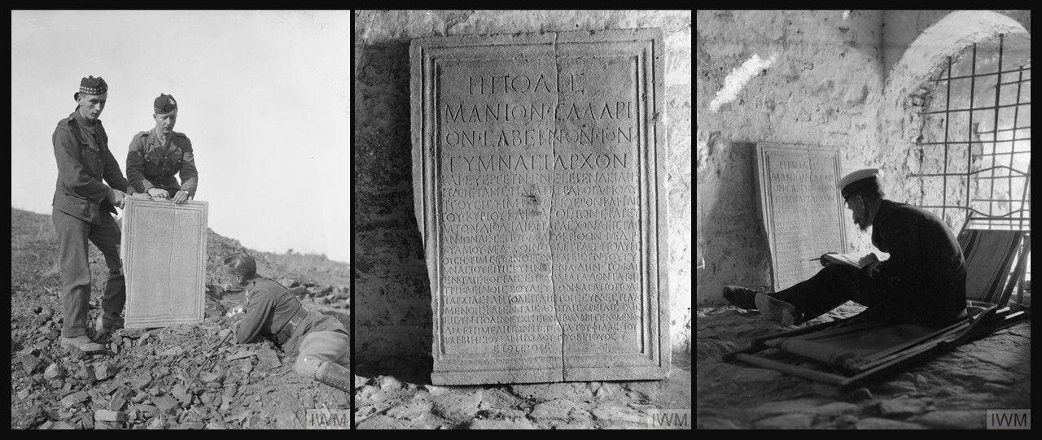

Photographer: Ariel Lowe Varges, American, 1890–1972
Discovery of the ancient marble memorial plaque praising the virtues of Manius Salarius Sabinus for his benefactions by the 8th Battalion, Royal Scots Fusiliers whilst digging trenches on part of the Birdcage Line defences between the villages of Aivatli and Laina (ancient Lete), April 1916, (in the Collection of the Archaeological Museum of Thessaloniki), Photo date: 1916 – Photo Credit: Imperial War Museums, UK https://www.iwm.org.uk/collections/item/object/205297459
The ancient marble memorial plaque praising the virtues of Manius Salarius Sabinus for his benefactions (in the Collection of the Archaeological Museum of Thessaloniki), Photo date: 1916 – Photo Credit: Imperial War Museums, UK https://www.iwm.org.uk/collections/item/object/205297460
Lieutenant Commander Ernest Gardiner R.N.V.R. working on the ancient marble memorial plaque praising the virtues of Manius Salarius Sabinus for his benefactions, Photo date: 1916 - Photo Credit: Imperial War Museums, UK https://www.iwm.org.uk/collections/item/object/205265524

Here are some student activity ideas inspired by Ariel Varges’s photographs of the discovery of the Manius Salarius Sabinus plaque by British troops during WWI:

1. Photo Analysis & Storytelling
Students examine the three photographs closely (soldiers uncovering the plaque, close-up of the inscription, Gardiner studying it). They are asked to:
- Describe what they see in each photo.
- Imagine the thoughts of each figure (soldier, officer, archaeologist) and write a short diary entry or letter from that perspective.

2. Ancient Voice in the Classroom
Students read aloud the Greek inscription and its English translation. They then compose a modern “citizen’s decree” praising someone in their community (teacher, volunteer, classmate) for generosity or service—paralleling how Sabinus was honored in antiquity.

3. War & Archaeology Debate
Split the class into groups to debate: “Should soldiers be allowed to excavate and remove antiquities during wartime?” Each side uses Varges’s photos and the Sabinus plaque as case studies, considering ethics, preservation, and historical value.

