Role Play: Art Historian for a Day
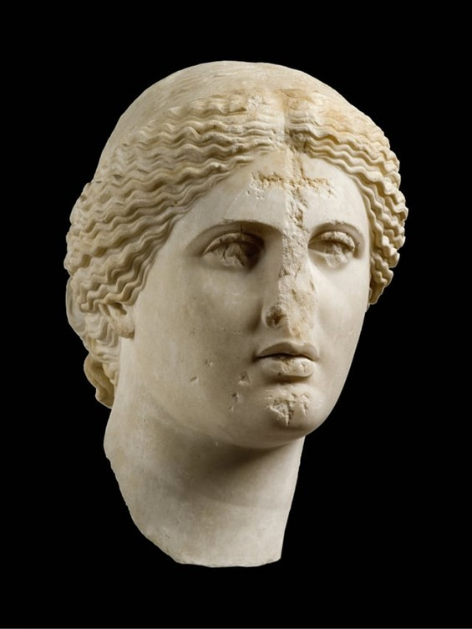
Head of Aphrodite of the Aspremont-Lynden/Arles type, 1st c. AD copy of an original 4th century BC work by Praxiteles, Marble, possibly Parian (Marathi), Height: 32 cm, National Archaeological Museum, Athens, Greece
https://blogs.getty.edu/iris/the-christian-empire-that-grew-from-classical-roots/

Role Play: Art Historian for a Day is student activity, designed to deepen historical and critical thinking:
Objective:
To develop critical research, analytical interpretation, and public presentation skills through the in-depth study of the Head of Aphrodite of the Aspremont-Lynden/Arles type, encouraging students to engage with ancient sculpture as both historical artifact and cultural symbol.
Instructions:
Students work in pairs to simulate a guided tour presentation at the National Archaeological Museum of Athens. Each pair will divide roles:
- Presenter 1 (Curator/Historian): Delivers a 5–7 minute analytical talk focused on the sculpture’s stylistic features, iconography, material, provenance, and its typological link to the Arles Aphrodite and broader classical ideals. They must draw on visual analysis and scholarly interpretations (assigned readings or independent research).
- Presenter 2 (Engagement Specialist): Prepares for a Q&A session by anticipating audience questions about historical context (e.g., Roman copies of Greek originals, the political or religious use of Aphrodite imagery) and responding critically using evidence-based reasoning.
Assessment Criteria:
- Accuracy and depth of research
- Use of appropriate art historical terminology
- Analytical insight into the sculpture's formal elements and cultural role
- Clarity, structure, and confidence in presentation
- Ability to interpret and respond to complex questions critically
Extension Option:
Have students record or perform their tour, followed by a group critique and discussion on how public interpretation shapes our understanding of ancient art.

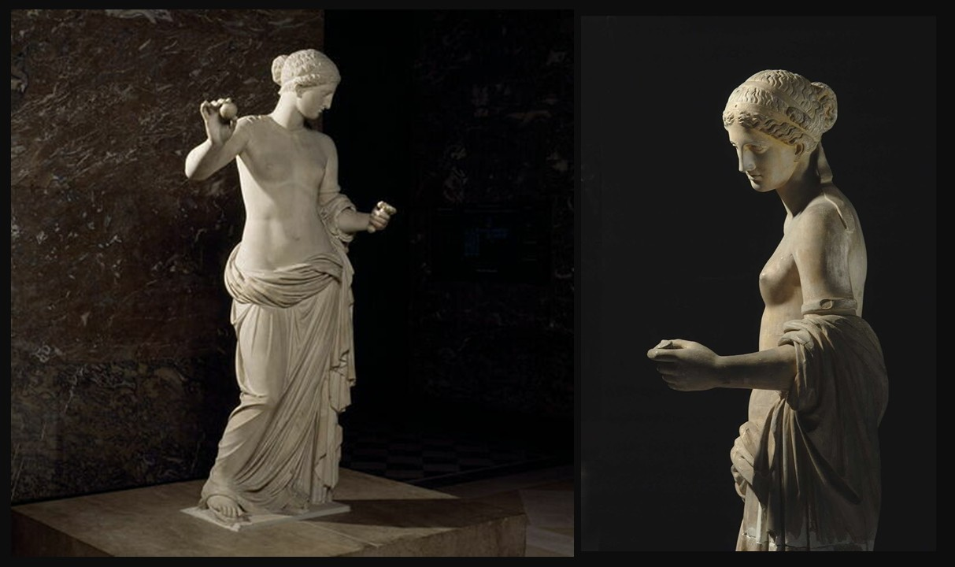
Vénus d'Arles, 4th quarter 1st century BC, Hymettus marble, Height: 220 cm, Louvre Museum, Paris, France (The arms, the nose, the neck were redone by Girardon. The bust and the folds were reworked by François Girardon, during the 17th century)
https://collections.louvre.fr/en/ark:/53355/cl010277986

