Blossoms in Time: Exploring Art, Nature, and Culture through Morning Glories by Suzuki Kiitsu

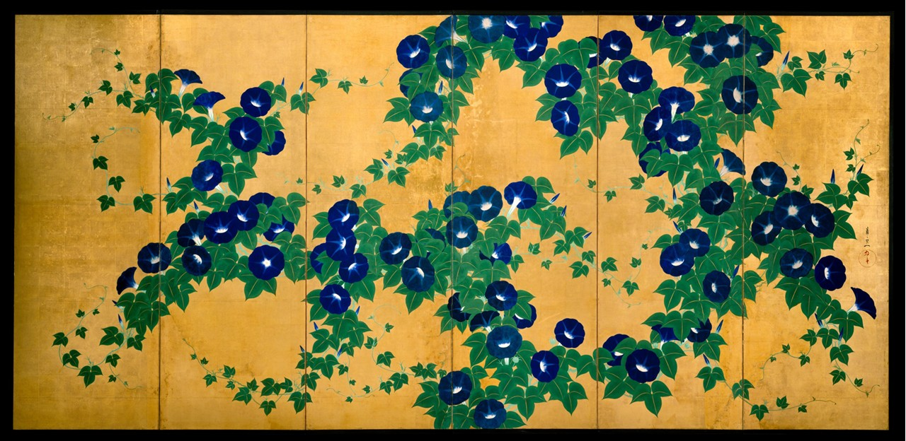

Suzuki Kiitsu, Japanese Artist, 1796–1858
Morning Glories, Edo period (1615–1868), early 19th century, Pair of six-panel folding screens; ink, color, and gold leaf on paper, Eeach Screen: 178.3 x 379.7 cm, the MET, NY, USA
https://www.metmuseum.org/art/collection/search/48982

Here are 3 Student Activities inspired by Suzuki Kiitsu's Morning Glories folding screens at the Metropolitan Museum of Art:

- Nature-Inspired Screen Painting (Art/Visual Arts)
Students create their own folding screen panel or triptych inspired by a flower or plant of their choice. Using watercolors or ink, they explore traditional Japanese painting techniques like flat color application, negative space, and gold/silver backgrounds.
- Haiku Writing with Visual Cues (English/Creative Writing)
After observing Morning Glories, students write a series of haiku that reflect the mood, setting, and natural beauty depicted in the screens. They then pair their haiku with small illustrations of Morning Glories or other flora.
- Mindfulness and Observation Exercise (Mindfulness/Art Appreciation)
Students engage in a slow-looking activity with Kiitsu’s screens, noting details such as brushstrokes, rhythm, and repetition. Followed by a short meditation or reflective journaling session on how the artwork evokes a sense of calm and impermanence.

