Jeff Koons' Tulips

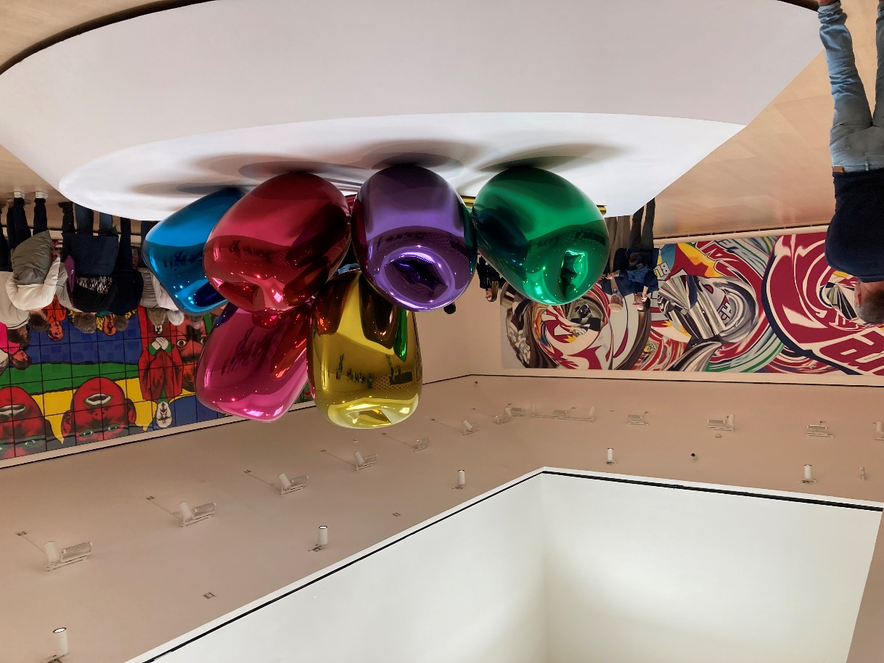
Jeff Koons, American Artist, 1955
Tulips, 1995–2004, High chromium stainless steel with transparent colour coating, 203x460x520 cm, Guggenheim, Bilbao, Spain - Photo Credit: Amalia Spiliakou, May 2024
Student Activities

Pop Culture and Art Collage:
Have students create a collage that explores themes of consumerism and pop culture, drawing inspiration from Koons' incorporation of everyday objects. Students can cut out images from magazines, advertisements, or online sources to represent mass culture and arrange them in a way that challenges or reflects on consumerism, much like how Koons critiques modern materialism in his works.
Balloon Sculpture Challenge:
Inspired by the balloon-like shapes in Tulips, students can use balloons, paper mâché, or other lightweight materials to create their own large, colourful sculptures. This hands-on activity can lead to discussions on how Koons transforms ordinary objects into monumental art, encouraging students to think about scale and how size changes the impact of a work.
Art Critique and Reflection Writing:
After learning about Koons’ Tulips, students can write a reflection or critique of the artwork, focusing on its themes of beauty, artificiality, and mass production. This activity encourages critical thinking as students analyze the sculpture’s meaning and its connection to consumer culture, while also exploring how Koons manipulates viewer perception through materials and scale.

