Nemesis
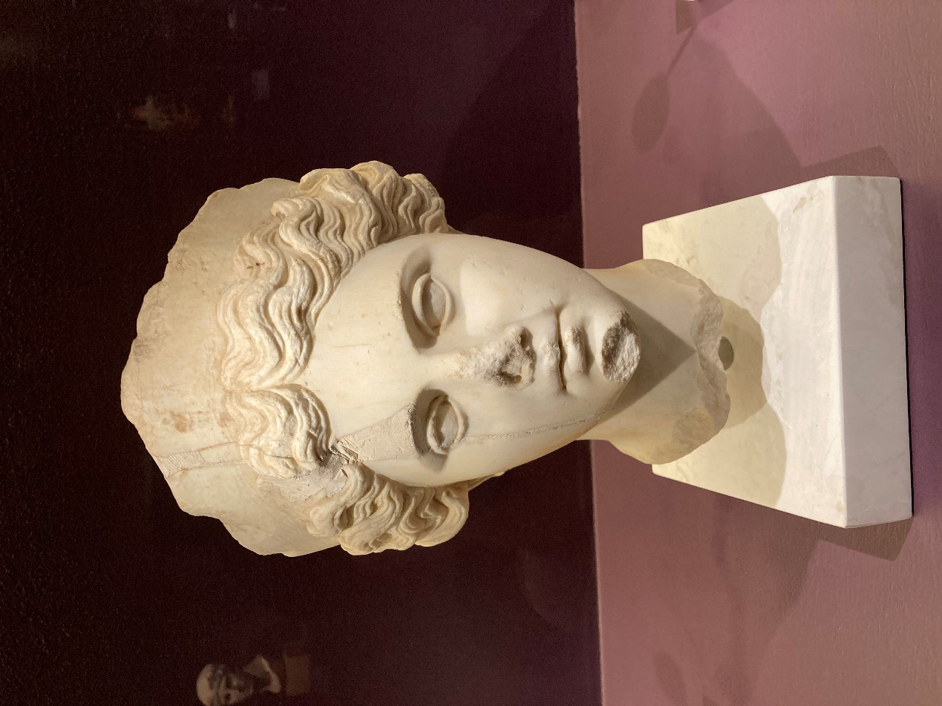
Head of Nemesis, the personification of attribution of Justice, 2nd century AD, Marble, Museum of Ancient Agora, Athens, Greece - Photo Credit: Amalia Spiliakou, February 18, 2024, ‘Meanings’. Personifications and Allegories from Antiquity to Today Exhibition, Acropolis Museum, Athens, Greece
Here is a Student Activities related to the ancient Greek goddess Nemesis, the goddess of retribution, justice, and balance:

Mythology Storyboard Creation
Objective: Create a visual storyboard depicting the major myths involving Nemesis.
Activity: Students will research stories like Nemesis and Narcissus, or the role of Nemesis in punishing hubris. They will then design a storyboard with images and captions summarizing key points. Students can use digital tools or hand-draw the scenes to visually represent the myth.
Skills Developed: Research, creativity, visual storytelling.

