The Rampin Rider

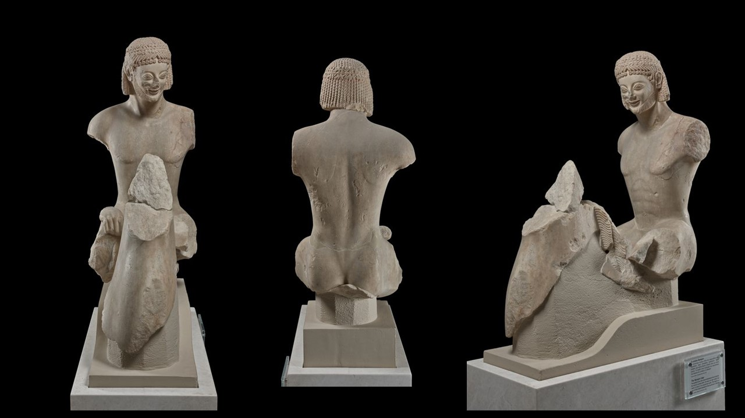
The Rampin Rider, Archaic Period, around 550 BC, Marble from Paros, Height: 1.08 m, Length: 0.77 m, Width: 0.38 m, Acropolis Museum, Athens, Greece https://www.theacropolismuseum.gr/en/statue-rider-rampin-rider

Student Activity: Exploring Ancient Greek Equestrian Culture through the Rampin Rider
Objective:
Students will explore the significance of horses and equestrian culture in ancient Greece, inspired by the Rampin Rider statue. They will connect this historical understanding with a hands-on experience at a horse riding club or farm.
Activity Overview:
- Pre-Visit Classroom Session (1 Hour):
  - Introduction to the Rampin Rider: Begin with a short presentation on the Rampin Rider statue, its historical context, and its importance as a symbol of wealth and status in ancient Greece.
  - Discussion on Equestrian Culture: Discuss the role of horses in ancient Greek society, focusing on their use in warfare, sports, and as symbols of nobility.
  - Art and Symbolism: Examine the artistic details of the Rampin Rider, such as the wreath, "archaic smile," and anatomical features, and discuss what these elements tell us about the rider's identity and social status.
- Visit to Horse Riding Club/Farm/School (2-3 Hours):
  - Guided Tour: Students will visit a local horse riding club, farm, or school. During the tour, they will learn about the care, training, and roles of horses in modern society.
  - Interactive Session: Students will have the opportunity to observe or participate in basic horse riding lessons, learning about posture, balance, and control—skills that would have been essential for ancient Greek riders.
  - Comparative Discussion: After the ride, engage in a discussion comparing the modern experience with the ancient context. How do today's equestrian practices relate to what they learned about ancient Greek horse culture?
- Post-Visit Reflection Activity (1 Hour):
  - Reflective Writing: Students will write a short essay or create a visual presentation reflecting on their experience. They should connect their hands-on learning at the horse riding club with what they learned about the Rampin Rider and ancient Greek society.
  - Group Discussion: Facilitate a group discussion where students share their reflections and discuss how the visit deepened their understanding of the cultural significance of the Rampin Rider and horses in ancient Greece.
Materials Needed:
- Access to images and resources about the Rampin Rider statue
- Writing materials or digital devices for essays/presentations
- Permission slips and arrangements for the visit to the horse riding club/farm
Assessment:
- Participation in discussions and activities
- Quality of reflective essays or presentations
- Engagement during the visit and ability to make connections between the ancient and modern equestrian experiences
This activity provides a multidisciplinary approach to learning, combining history, art, and physical education, while offering students a memorable, hands-on experience.

