Unraveling Goya's Cartoons and Tapestries

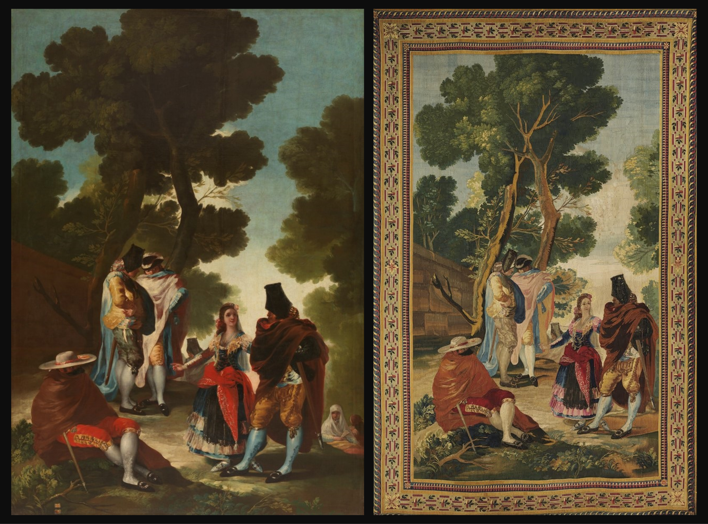
Francisco de Goya y Lucientes, 1746-1828
An Avenue in Andalusia, or The Maja and the Cloaked Men, 1777, Oil on Canvas, 275x190 cm, Prado Museum, Madrid, Spain https://www.museodelprado.es/en/the-collection/art-work/an-avenue-in-andalusia-or-the-maja-and-the/a4af7051-a0c2-4a63-8aef-5fa080890873
An Avenue in Andalusia or The Maja and the Cloaked Men, 1777, Royal Tapestry Factory, from a Goya cartoon, Tapestry - Wool and silk, 337x217 cm, Santiago de Compostela Cathedral Collection, Spain https://artsandculture.google.com/asset/an-avenue-in-andalusia-or-the-maja-and-the-cloaked-men-royal-tapestry-factory-from-a-goya-cartoon/mAFzZaxpTqLttA

Student Activity Objective:
To gain a deeper understanding of Francisco Goya's tapestries and cartoons, exploring their themes, techniques, and historical context.

Introduction to Goya: Start by providing a brief overview of Francisco Goya's life and artistic career. Highlight his significance as a Spanish painter and printmaker, and mention his exploration of various themes in his work, from political and social commentary to psychological insight.

Understanding Tapestries and Cartoons: Explain the distinction between Goya's tapestries and cartoons. Tapestries refer to the large woven works produced in collaboration with the Royal Tapestry Factory, while cartoons are the preparatory sketches Goya made for these tapestries.

Analysis of Themes: Introduce the Goya’s Cartoon/Tapestry An Avenue in Andalusia, or The Maja and the Cloaked Men, for analysis. Discuss the artist’s masterful exploration of costumbrista themes, his unique way of presenting the vibrant world of 18th-century Andalusia, and how he captures the essence of everyday life through keen observation and wit. Encourage participants to share their interpretations and reactions.

Techniques and Style: Explore Goya's artistic techniques and style as seen in his tapestries and cartoons. Discuss his use of composition, color, line, and symbolism. Compare and contrast his approach to these mediums with his paintings and prints.

Historical Context: Provide historical context for Goya's tapestries and cartoons, particularly regarding the political and social climate of late 18th and early 19th-century Spain. Discuss how Goya's work reflects the tumultuous events of his time, including the Napoleonic Wars and the Spanish Inquisition.

Creative Response: Encourage participants to create their own artwork inspired by Goya's tapestries and cartoons. They can choose to explore similar themes or experiment with Goya's techniques in their own style.

Discussion and Reflection: Facilitate a discussion on the significance of Goya's tapestries and cartoons in art history and their relevance to contemporary issues. Encourage participants to reflect on what they've learned and how it has deepened their appreciation for Goya's work.

Optional Extension: For those interested in further exploration, suggest visiting museums or galleries that exhibit Goya's tapestries and cartoons, or recommend books and online resources for additional study.

By engaging in this activity, participants can gain a richer understanding of Goya's artistic legacy and the enduring impact of his tapestries and cartoons.

