Capturing Hellenistic Dance
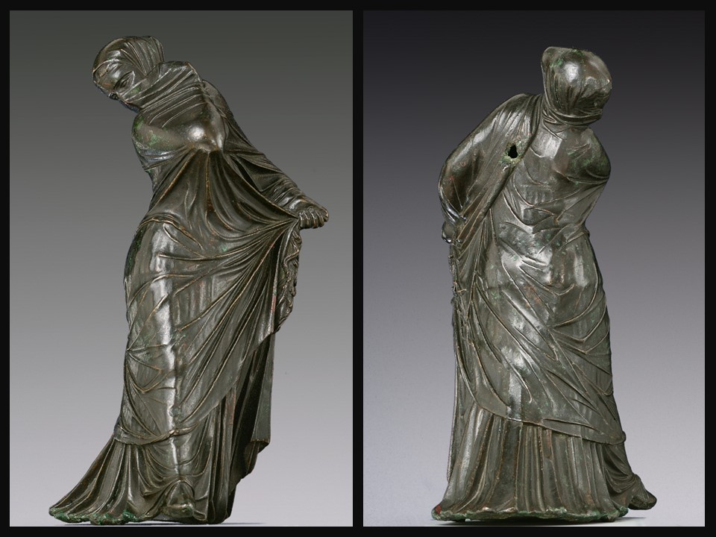
Bronze statuette of a veiled and masked dancer, 3rd–2nd century BC, Bronze, 20.5 × 8.9 × 11.4 cm, the MET, NY, USA https://www.metmuseum.org/art/collection/search/255408?pkgids=351&pos=20&nextInternalLocale=en&ft=*&oid=255408&rpp=4&exhibitionId=%7Bc81fa618-19f5-47a1-a089-fd1b22309109%7D&pg=1
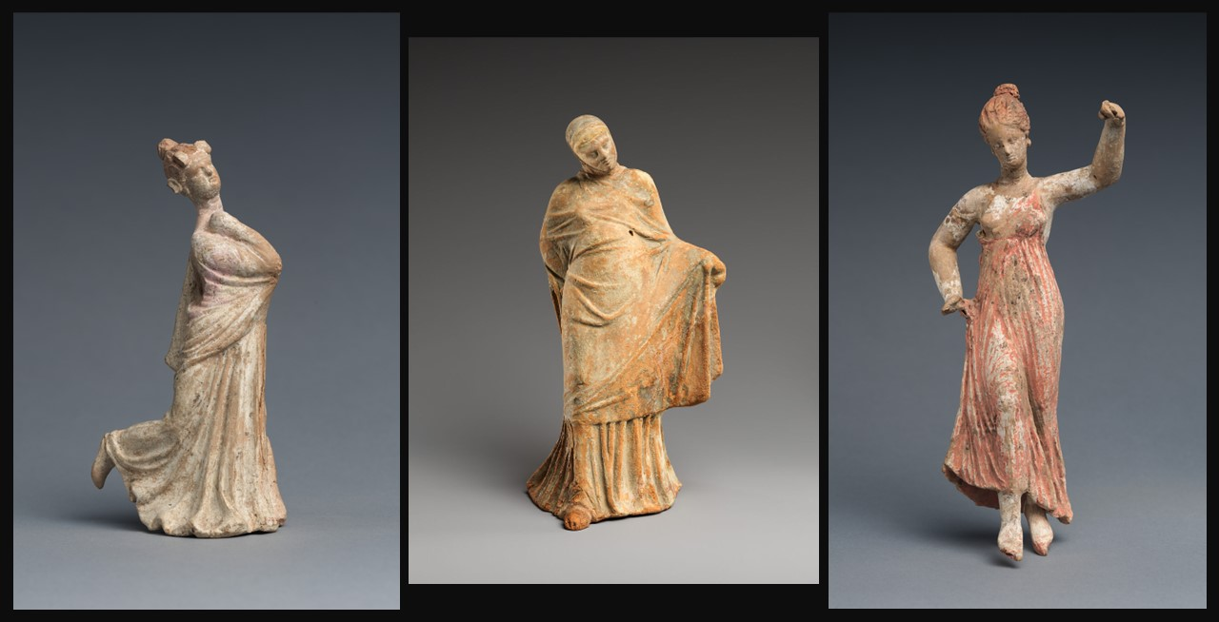
Terracotta statuette of a Dancing Woman, 3rd century BC, Terracotta, 24.1 × 10.2 × 8.3 cm, the MET, NY, USA https://www.metmuseum.org/art/collection/search/248712
Terracotta statuette of a Dancing Woman, 3rd century BC, Terracotta, 15.2 × 6.2 × 8.6 cm, the MET, NY, USA https://www.metmuseum.org/art/collection/search/248601
Terracotta statuette of a Veiled Dancer, 3rd century BC, Terracotta, H. 20.0 cm, the MET, NY, USA https://www.metmuseum.org/art/collection/search/251216

Objective
To create a living representation (Tableau Vivant) inspired by the Hellenistic statuettes of dancers, incorporating elements of pose, emotion, and cultural context.

Materials
Images or replicas of Hellenistic statuettes, Simple costumes or fabric for draping, Open space for performance, Background music

Activity Steps

Introduction: Start with a brief overview of Hellenistic dance and its portrayal in statuettes. Discuss the key features, such as dynamic poses, flowing garments, and the emotional expressiveness of the dancers.
Observation and Analysis: Show images of Hellenistic statuettes to the students. Discuss the various poses, expressions, and cultural elements represented. Encourage students to identify emotions conveyed by the dancers.
Role Assignment: Divide students into small groups and assign each group a specific Hellenistic statuette or pose to recreate. Ensure that each member has a role in embodying the pose or contributing to the overall tableau.
Costume Preparation: Provide simple costumes or fabric for draping to enhance the visual representation. Allow students to collaborate on creating costumes that capture the essence of the Hellenistic garments seen in the statuettes.
Rehearsal: Give students time to rehearse their assigned tableau vivant. Encourage them to pay attention to details such as facial expressions, body language, and the overall composition of the living sculpture.
Performance: Arrange for a space where each group can present their tableau vivant to the class. Allow time for each group to perform and provide a brief explanation of the chosen statuette and their creative choices.
Group Reflection: After each performance, facilitate a brief group reflection. Encourage students to discuss the challenges faced, the creative decisions made, and the overall experience of embodying the Hellenistic dance form.
Class Discussion: Conclude the activity with a class discussion on the significance of the Tableau Vivant in capturing the spirit of Hellenistic dance. Discuss how the activity deepened their understanding of the cultural and artistic elements of the statuettes.

Conclusion
The Tableau Vivant activity provides students with a hands-on, creative experience to connect with the art and culture of the Hellenistic period, fostering a deeper appreciation for the expressive nature of dance as depicted in ancient sculptures.

