Exploring the Depths of Sleeping Eros

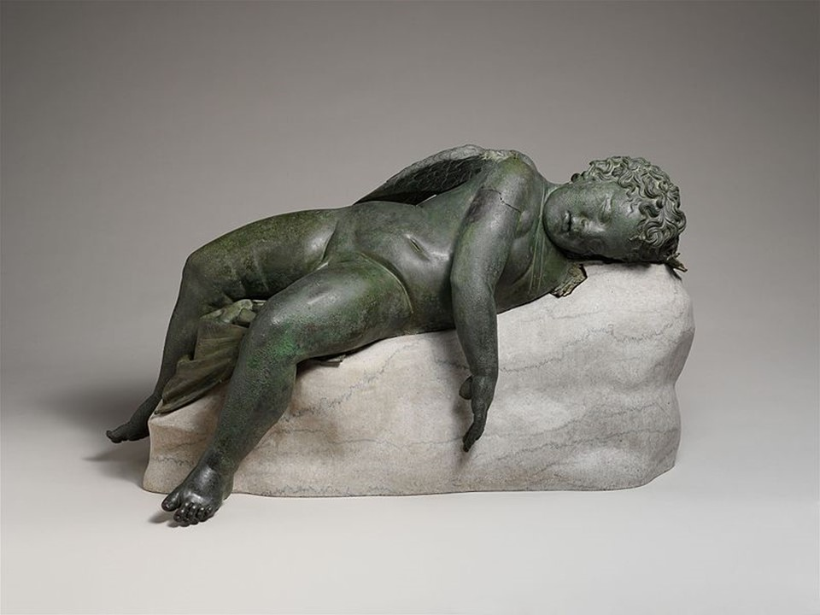
Bronze statue of Eros sleeping, 3rd–2nd century BC, Bronze, 41.9 × 35.6 × 85.2 cm, the MET, NY, USA https://en.m.wikipedia.org/wiki/File:Bronze_statue_of_Eros_sleeping_MET_DP123903.jpg

Project Objective: Students are asked to spend time observing the projected on the classroom screen pictures of the Sleeping Eros MET statue. They are encouraged to take notes on its physical characteristics, pose, and any details that stand out.

Research: Students are instructed to research the cultural and mythological significance of Eros in ancient Greek society.

Creative Writing: Students are encouraged to imagine a narrative or story behind the Sleeping Eros. What might have led to this peaceful slumber? What emotions or events could be associated with this moment? Ask them to write a short creative piece capturing the essence of the statue.

Class Discussion and Presentation: The class is brought together for a discussion where students can share their observations, research findings, and imagined stories. Students are asked to reflect on how the 'genre' introduced in Hellenistic art is evident in Sleeping Eros.

This activity encourages students to engage on multiple levels, fostering critical thinking, research skills, and creative expression.

