The Hours of Jeanne d'Evreux, Queen of France

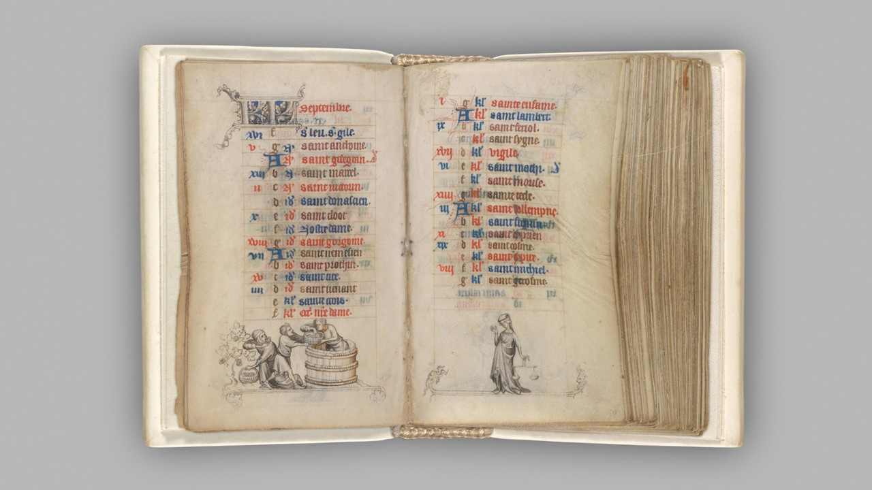
Jean Pucelle, French, active Paris, 1319–34
The Hours of Jeanne d'Evreux, Queen of France, Folios 9v-10r, Calendar Pages for September, ca. 1324-28, Grisaille, tempera, and ink on vellum, Single folio: 9.2 x 6.2 cm, the MET, NY, USA Jean Pucelle | The Hours of Jeanne d'Evreux, Queen of France | French | The Metropolitan Museum of Art (metmuseum.org)

Illumination Workshop
Team up with the school’s department of Visual Arts and organize an illumination workshop where students can learn about the art of manuscript illumination.
Provide students with materials like parchment paper or cardstock, calligraphy pens, and metallic paints.
Guide them through the process of creating their own illuminated initials or small illustrations, incorporating elements inspired by
The Hours of Jeanne d'Evreux.

