Tiffany's Table Lamp Fish and Waves
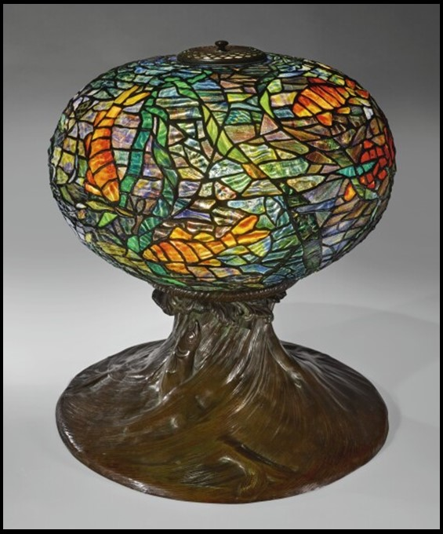
Louis Comfort Tiffany, American artist, 1848 – 1933 - Tiffany Glass and Decorating Company
Fish and Waves Table Lamp, attributed to Clara Driscoll, circa 1900- Paul Doros1903, Leaded Glass, patinated bronze, H. 38.1 cm, Private Collection
https://www.sothebys.com/en/articles/tiffanys-aquarium-in-stained-glass

The Tiffany "Fish and Waves" table lamp is a beautiful piece of art that can inspire various student activities related to art, design, and history.
This is a Poster-Activity for students to work on.
Each Poster should include the following three parts:

Tiffany Studios History: Students are asked to research the history of Tiffany Studios and Louis Comfort Tiffany. Discuss the impact of Tiffany's work on American art and design and his influence on the Art Nouveau movement. Students are expected to write a three paragraph essay of their research finds.

Creative Writing Exercise: Inspire students to write a short story or poem based on the "Fish and Waves" table lamp. They could imagine a story taking place in an underwater world or explore the thoughts and feelings of Koi, Japanese gold fish, depicted in the design.

Design Your Own Tiffany Lamp: Encourage students to design their own Tiffany-style table lamp, incorporating elements from the "Fish and Waves" design or creating something entirely new. Students can sketch their designs, create a digital rendering, or even build a physical model.

