Élisabeth Louise Vigée Le Brun
in Words and Music

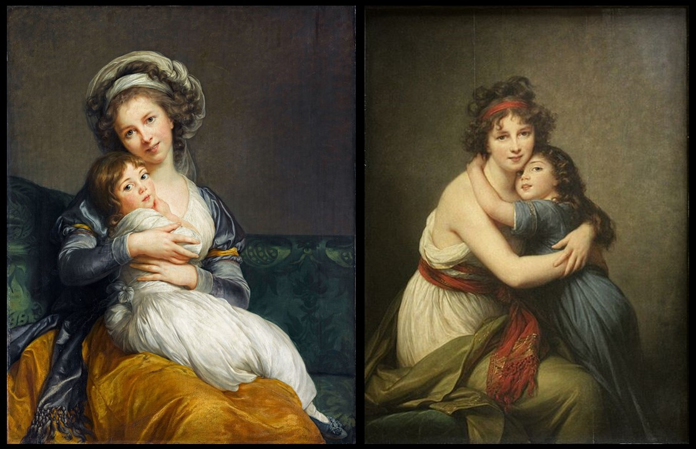

Élisabeth Louise Vigée Le Brun, French Artist, 1755–1842
Self-portrait with Her Daughter, Julie, 1786, oil on panel, 105 × 84 cm, the Louvre, Paris, France https://histoire-image.org/etudes/nouveau-visage-amour-maternel
elf-Portrait with Her Daughter, Julie (à l’Antique), 1789, oil on canvas, 130x94 cm, the Louvre Museum, Paris France https://commons.wikimedia.org/wiki/File:Self-portrait_with_Her_Daughter_by_Elisabeth-Louise_Vig%C3%A9e_Le_Brun.jpg

This is an Interdisciplinary Student Activity with the School’s Music Department

Step 1: Write a descriptive Paragraph:
Students are asked to look closely at the two Self-Portrait paintings by Élisabeth Louise Vigée Le Brun holding her daughter Julie and write a paragraph describing what they see. Students should be encouraged to use descriptive language to paint a picture with words.
Step 2: Create a soundtrack:
Students are asked to listen to different pieces of music and select one that they feel captures the mood and tone of the two paintings. Students are expected to explain their choice and create a playlist of songs that would be appropriate to play while looking at the two paintings.

