The Bersha Procession
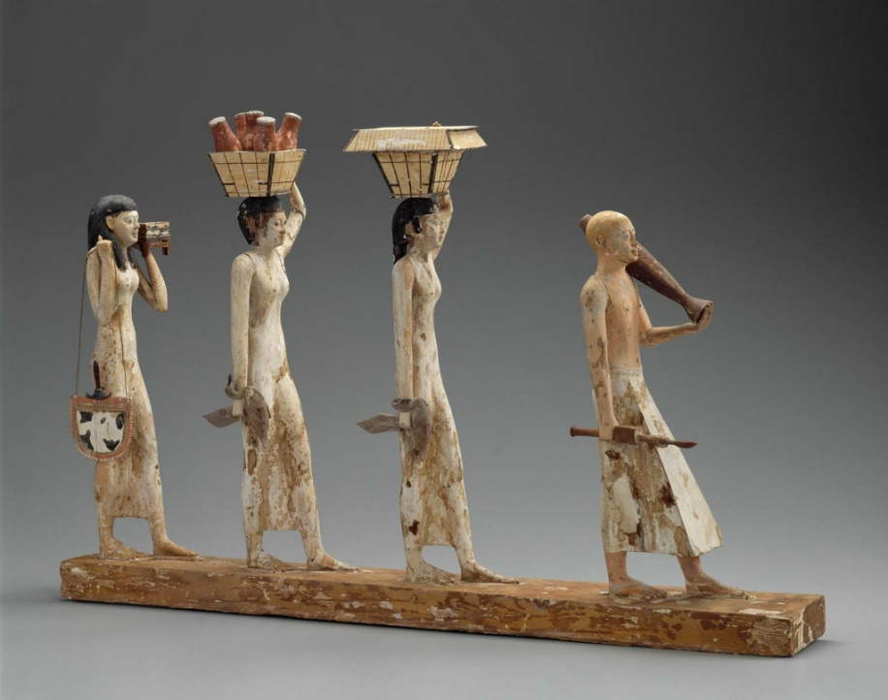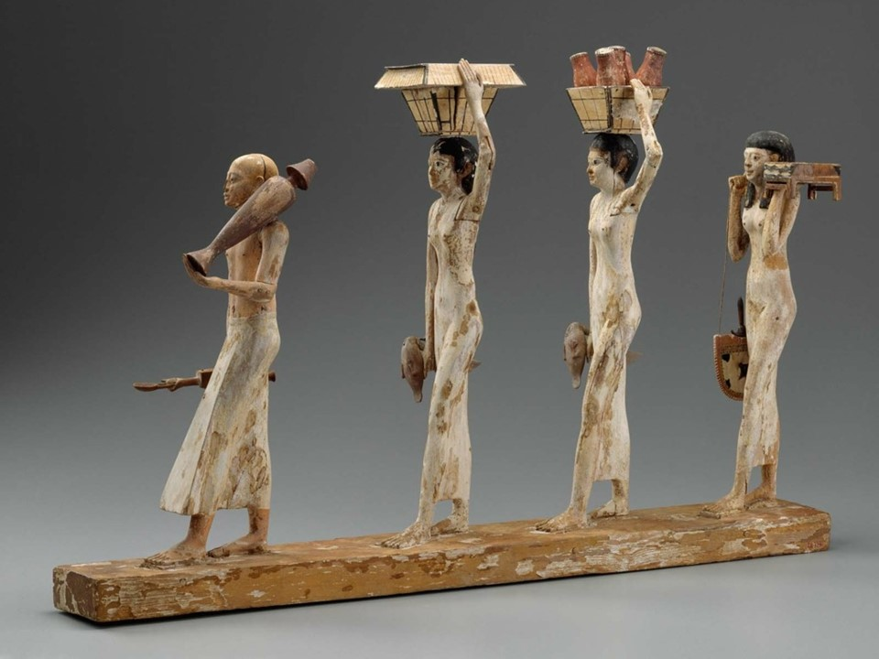
The Bersha Procession, 2010–1961 BC, Egyptian Middle Kingdom, late Dynasty 11 – early Dynasty, Findspot: Egypt, Deir el-Bersha, Tomb 10, shaft A (Djehutynakht), Painted Wood, 66.4 x 8.6 x 42.5 cm, MFA, Boston, USA https://history2701.fandom.com/wiki/The_Bersha_Procession
The Bersha Procession, is a wooden model from the late 11th dynasty (2010–1961 BC). Found in Dir el-Bersha, on the east bank of the Nile, the Middle Kingdom model was recovered from the tomb of Djehutynakht. It depicts a priest carrying wine and incest, followed by two women carrying food and drink and a third women bringing items of personal care. Today, it is exhibited in the Museum of Fine Arts, in Boston, USA . https://history2701.fandom.com/wiki/The_Bersha_Procession
Everything you know about the Bersha Procession…
When? | Where? | Who? | Why? | How? | What?

