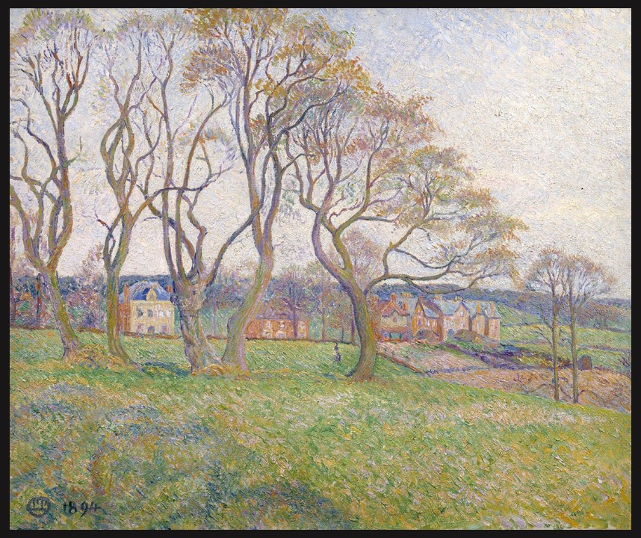
Lucien Pissarro, French Artist, 1863–1944
April, Epping, 1894, Oil paint on canvas, 603 × 730 mm, Tate, London, UK
https://www.tate.org.uk/art/research-publications/camden-town-group/lucien-pissarro-april-epping-r1139298

Inspired by Lucien Pissarro… April, Epping

This Activity is based on the Learning to Look method created by the Hood Museum of Art. This discussion-based approach will introduce you and your students to the five steps involved in exploring a work of art: careful observation, analysis, research, interpretation, and critique. Practice IN-CLASS the first steps and at the end ask students to write as a formative assessment the final Critique.
Critical Assessment and Response: It’s time to JUDGE how successful the work of art on focus is! This is an important part of the Learning Process and students are asked to answer the provided questions supporting their opinions based on their work done so far, “Critical assessment involves questions of value.” For example:
- Do you like this work of Art?
- How do you feel about this painting?
- Do you think Lucien Pissarro’s painting ‘April, Epping’ was successful and skillful in expressing the painter’s ideas?
- Is the painting still relevant to your life and your culture?

