The Enkolpion of Empress Maria
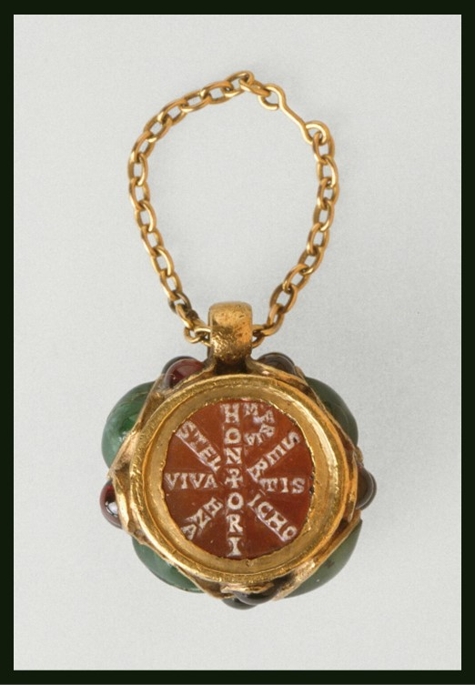
Enkolpion of Empress Maria, 398-407, Agate Cameo, Gold, Ruby or Garnet, Emerald, 2.6x1.8x1 cm, the Louvre, Paris, France
https://www.doaks.org/research/byzantine/scholarly-activities/dynastic-jewels-a-late-antique-rhetoric-of-treasure-and-adornment

Introduce vocabulary associated with the Louvre Enkolpion…
Students are expected to write the Essential Meaning for the following terms…
Enkolpion
Cameo
Christogram
Mausoleum
Sarcophagus
Rotunda

