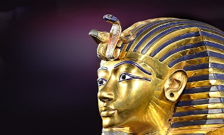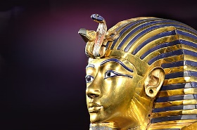
Timeline

Second Intermediate period (ca. 1630 - 1539/1523 BC)
Dynasty 15 (ca. 1630 - 1523 BC)
Dynasty 16 (dates unknown: minor Hyksos rulers, contemporary with Dynasty 15)
Dynasty 17 (ca. 1630 - 1539 BC)

NEW KINGDOM (ca. 1539 - 1075 BC)
Dynasty 18 (ca. 1539 - 1292 BC)
Dynasty 19 (ca. 1292 - 1190 BC)
Dynasty 20 (ca. 1190 - 1075 BC)

Third Intermediate Period (ca. 1075 - 656 BC)

Late Period (ca. 664 - 332 BC)

Macedonian Period (ca. 332 - 305 BC)

Ptolemaic Dynasty (ca. 305 - 30 BC)

Roman and Byzantine Empire (ca. 30 BCE. - 642 AD)

