A Still Life of Flowers
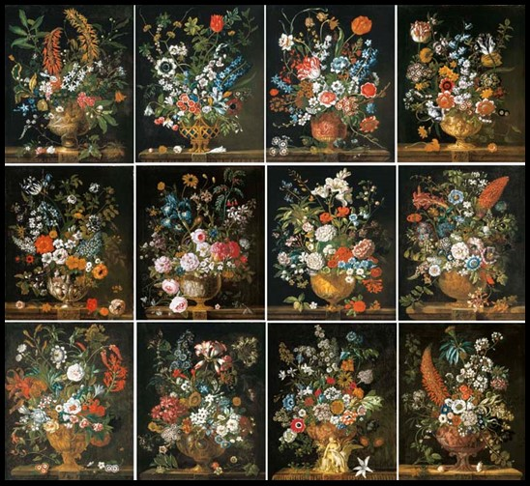

Pieter Casteels III, 1684-1739
The Twelve Months of Flowers, 1730, Oil on Canvas, 76.2x63.5 cm, Private Collection
https://www.christies.com/lot/lot-pieter-casteels-iii-antwerp-1684-1749-richmond-4507868/?

- Students are asked to create a still-life of flowers.
- Students are expected to consider the parameters of their composition, and which colour scheme they would like to use. They are encouraged to add texture, use a range of materials, and to experiment with various techniques.
- When finished, students compare their work with examples of other students’ Still Life paintings and identify similarities in composition, use of materials, techniques, colours, line, and shapes.

