Miniature Mosaic Icon of Saint Demetrios in Sassoferrato

Introduce vocabulary associated with the Miniature Mosaic Icon in Sassoferrato.  Students are expected to write the Essential Meaning if the following terms…  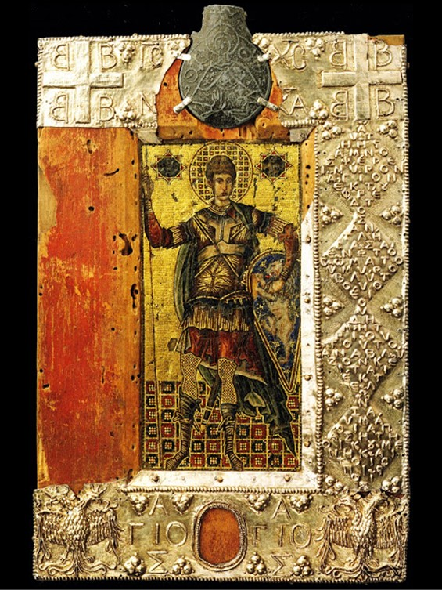  Mosaic Icon of Saint Demetrios at Sassoferrato, Mosaic Icon: 14th or 15th century, Ampulla: 13th or 14th century, Silver Frame: mid-15th century, Mosaic set into wax on a poplar board, paint, silver-gilt (frame), lead (ampulla), 24.3 X 16 cm, Museo Civico, Sassoferrato, Italy https://www.johnsanidopoulos.com/2015/11/a-14th-century-byzantine-icon-of-st.html | Micromosaic  Tetrabasileion  Reliquary  Ampulla  Heraldic

