Sagittarius Constellation and Greek Mythology!
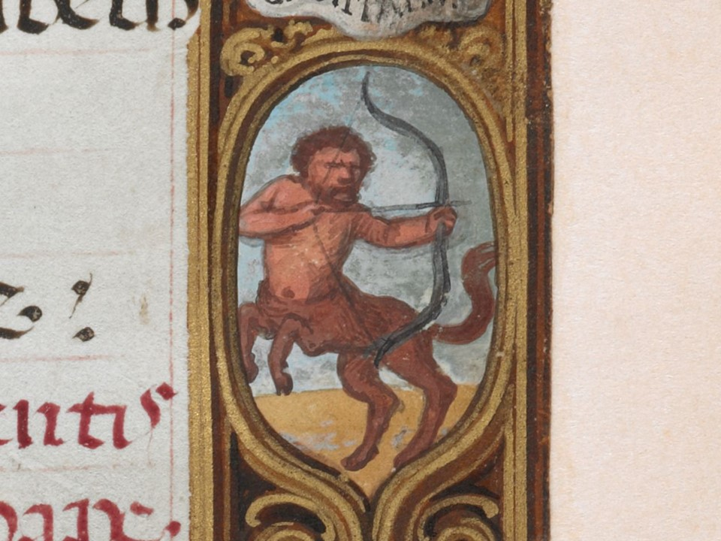
Simon Bening (d. 1561) and workshop
Book of Hours, known as the Golf Book, November (f. 29r) (detail), c. 1540, Parchment leaves on paper mounts, bound into a codex. 110x80 mm, British Library, London, UK
https://blogs.bl.uk/digitisedmanuscripts/calendars/page/11/

Sagittarius is a large Constellation in the southern celestial hemisphere.
Sagittarius is one of the 48 constellations listed by the 2nd century astronomer Ptolemy, and remains one of the 88 modern constellations today. Sagittarius is commonly represented as a centaur drawing a bow.
For the ancient Greeks, the Constellation of Sagittarius is related to the Mythological story of Chiron, the immortal Centaur, the teacher of many ancient Greek heroes…

Students are asked to research and explore the Myth of Zeus and Europe
through Internet sites and write a paragraph explaining how the Myth is related to the Constellation of Sagittarius
This is an Activity students can do for every Zodiac Sign painted in the Book of Golf by Simon Bening!

